Iggy’s
Pre-Made Doughboy Mix

“A Sweet Nigerian Delicacy”

Export Plan
Elisabeth Loiselle, Samantha Eynon, Savannah Rode, Dara DiMaiolo

TABLE OF CONTENTS
Executive Summaries
Cultural Analysis ………………………….……………………………..……………….3
Economic Analysis…………………………….……………………………..…………...4
Market Audit and Competitive Analysis…….…………………………………………... 5
Preliminary Market Analysis…………………………..……………………………….... 6

Cultural Analysis
Company Introduction and Brief History……………………………………………….. ..7
Country History……………………………………………………………………………9
Geographical Setting……………….…………………………………………………….14
Social Institutions………………………………………………………………………...16
Religions and Aesthetics…………………………………………………………………22
Living and Conditions…………………………………………………………………....25
Language……………………………………………………………………...………….31

Economic Analysis
Population………………………………………………………………………………..34
Economic Statistics and Activity…………………………………………...……………36
Development in Science and Technology………………………………….…………….45
Channels of Distribution…………………………………………………………………47
Media………………………………………………………………………………….....48

Market Audit and Competitive Analysis
Product…………………………………………………………………………………...53
The Market……………………………………………………………………………….57

Preliminary Marketing Plan
The Marketing Plan………………………………………………………………………65

Appendix
Sample Advertisements……………………………………………………………….....81

Executive Summary- Cultural Analysis
This section provided a summary and in-depth analysis of the culture and customs in Nigeria. The Nigerian familial dynamic, the role of education, the political and legal systems, religion and arts, and dialects were heavily explored and examined. All of these factors and characteristics contributed to an overall understanding of what Nigerians needed and provided insight into what type of product should be introduced in their society to meet those needs.
It is important to thoroughly understand the language dialects, diet, and nutrition of the country. The official language spoken in Nigeria is English, which is important to know when advertising the product and trying to reach customers. The diet and nutrition in Nigeria played a key role in deciding the product to bring to Nigeria as well. In Nigeria, it is extremely common for many people to fry their food, including Àkàrà (Fried Bean Cake) and Puff-Puff (Fried Sweet Dough Ball). Our product, Iggy’s premade doughboy mix, takes away the hassle of getting ingredients to make Àkàrà and Puff-Puff and gives Nigerians the option to have a fried meal ready to cook.
It is also important to understand the malnutrition rates in Nigeria and how Iggy’s can help the problem. About two in five Nigerian children are stunted by malnutrition with varying rates throughout the country. About 30% of Nigerian children are underweight (do not meet the proper weight for their age) and this number has steadily increased over the past decade. Sadly, each year, about 1 million Nigerian children die before their 5th birthday meaning malnutrition contributes to nearly half of all deaths. Iggy’s provides a quick and simple meal that can be easily accessed by many families. With the affordable prices and convenience of Iggy’s, many children and families can use it as a staple meal.

Executive Summary- Economic Analysis
In this section, exclusive research went into learning Nigeria’s Economic background. When dissecting the economic behavior in Nigeria, the primary force was the population, spending activity, the technological development of the country, types of distribution channels, and finally the most prevalent media types. Understanding all the details about how stable the country is, helped us decide what product would be the best fit for Nigeria.
Nigeria is a fast-growing populated country. They are one of the fourth most populated countries and are expected to continuously grow due to the high birth rates. This means the majority of the country is between ages 0-14, making up 47.1% of the total population within the country. Given this age distribution, it seemed fitting to provide a product that is fit for parents and children to use in a fun, new way.
Another factor that was looked at was Nigerian spending activity which provided an understanding of what types of products Nigerian people are buying, what they are willing to buy, and how much money they are making. Additionally, the country's Gross Domestic Product was $475.062 billion USD and the wealth was distributed into three different classes; upper, middle, and lower. The population is primarily split up between the lower, and middle classes, this makes up the majority of the population. Understanding this demographic helps determine product pricing.
Nigeria has a high usage rate of technology such as using phones, and radio, as well as having updated infrastructure. This is important when exporting because it shows there are distribution channels available both on-land and via ocean ports. This is helpful information for advertising as well as it shows the most-used and best platforms for product promotion.
Executive Summary- Market Audit and Competitive Analysis
This section is to provide information about the product being introduced into the Nigerian market: Iggy’s Doughboy Mix. This pre-made dough mix gives customers the option to make sweet doughboys from their own homes. Doughboys are unique to this market and its consumers because a “doughboy” is a foreign concept in Nigeria. The idea to sell this mix in Nigeria was inspired by the popularity of Puff-Puffs, a traditional Nigerian snack made from fried dough. An advantage our product has in this consumer market is that it is a new phenomenon, meaning there could be an eagerness to try it out of curiosity. Yet, with this unfamiliarity and Nigeria's strong preference for fresh food, there could be some resistance from customers initially.
Iggy’s Doughboy Mix will predominantly be sold in Lagos, Nigeria. Advertising will occur through TV, radio, and the internet/social media. The retail outlet in which the pre-made dough mix will likely be sold is Shoprite and Spar-Nigeria, large retail outlets located throughout Nigeria, similar to America’s Walmart.
The strongest competitor on the market is Darmol Food’s “Puff Puff Mix,” a pre-made mix that allows customers to make traditional puff-puff to alleviate stress. The product sells for a similar price on the Nigerian market that Iggy’s mixture does in the American market and both companies seem to advertise and distribute their products in a similar manner.
The Export-Import Bank of the United States will be critical to the successful exportation of Iggy’s Doughboy Mix. There are many Nigerian government regulations that must be followed when importing into the country, such as having the food inspected by a government agency or third party so having an export specialist in Iggy’s team is crucial to success as well.
Executive Summary- Preliminary Marketing Plan
The information in this section serves as a basis for presenting the most effective and creative means of marketing Iggy’s Doughboy Mix to Nigeria. As Nigerians enjoy fried foods, like Puff Puffs, the target market is going to be anyone who enjoys fried puffs. Our primary market will be the people within Eastern Nigeria as they eat foods such as Gari, which is a cassava powder used to make baked goods. Families with children will also be targeted because children in Nigeria enjoy the puffs and will likely be excited by a sweeter version of this common treat. This makes the age range for the target market 14-44 years, but it is not limited to this age group. This is simply the group of people the product will likely resonate with the most. We plan to sell the Doughboy Mix for $5 USD, as with this price, the 10% sales on the Doughboy Mix packages will bring in $1,200 USD of revenue and total sales for the first year.
Iggy’s Doughboy Mix packages will be adapted to appropriate metrics and to a design that is more appealing to Nigerian consumers. We will adapt the logo, slogan, and the amount that the doughboy mix ultimately produces. Advertising will be used as a way to make connections between puff puffs and Iggy’s Doughboys, and to educate consumers on the new item. Advertisements will have an overall message that is a sweet and delicious alternative to an existing delicacy that should be tried as soon as possible.
The purpose of Iggy’s product is to promote a sugary, deep-fried version of traditional Nigerian food to create new excitement about traditional food. The advantage of the internet and social media will be taken when it comes to reaching the target market, as a product website and social media advertising will be highly beneficial. Direct shipping will be out of the Port of New Jersey and New York into Lagos Port Complex in Apapa, Lagos State.
Cultural Analysis
Company Introduction and Brief History
Iggy’s is a Rhode Island-based and operated business that has been in operation for 25 years with its first location opening on Oakland Beach in Warwick, RI. Iggy’s was started by Gaetano “Guy” Gravino and is currently owned by his son, David Gravino, who took over upon the passing of his father. Iggy’s is renowned for its infamous doughboys along with clam cakes, stuffies, clam chowder, fried calamari, and other New England staples.
The business started as “Gus’s” beach stand in 1924 and has remained one of Rhode Island’s oldest clam shacks. David worked for his father and bought the business in 1989 to develop what is known today as Iggy’s. While Iggy’s most infamous dish is currently their sweet doughboys, originally the beach stand and restauranter featured their family's red chowder, made with a longstanding “secret recipe.”
In 2000, David began expanding the business by opening new locations beyond the original Oakland Beach restaurant. Iggy’s now has four locations across Rhode Island in Warwick and Narragansett, including two restaurants, “The Broadwalk,” and “The Creamery.” They cater events, host private events, and have online delivery and shipping that is available both locally and nationwide. They also have shopping on their website and in stores where customers can buy clothing, accessories, gifts, collectibles, “Iggy’s Pantry” items, “Iggy’s Gift Kits,” and more.
Iggy’s doughboys gained the most attention from locals and tourists due to their unique nature. Locals and visitors alike craved the taste of melting sugar against the warm, chewy dough beyond the confines of the Rhode Island border so this abundant popularity caused Iggy’s to offer the infamous doughboys in a pre-made mix available for purchase, both online and at local retail stores throughout Rhode Island. It is currently one of the few food items the restaurant offers that is available for independent preparation with a premade mixture. Nothing quite compares to getting a fresh doughboy on the windy shores of Oakland Beach, but having the opportunity to consume the sweet treat year-round in any place and at any time has left doughboy lovers everywhere extremely excited to purchase the product.

Country History
Relevant History
The national capital of Nigeria is Abuja, in the Federal Capital Territory, and was created by decree in 1976. Lagos was the former capital, but it is still the country’s leading commercial and industrial city. Lagos was occupied by British forces in 1851 and formally annexed by Britain in 1865. Nigeria became a British protectorate in 1901. The period of British rule lasted until 1960 when an independence movement led to the country being granted independence.
Nigeria first became a republic in 1963 but succumbed to military rule after a bloody coup d’état in 1966. A separatist movement later formed the Republic of Biafra in 1967, leading to a three-year Nigerian Civil War. Nigeria became a republic again after a new constitution was written in 1979. With that being said, the republic was not long-lived, as the military seized power again in 1983 and later ruled for ten years. A new republic was planned to be established in 1993 but was aborted by General Sani Abacha. Abacha died in 1998 and a fourth republic was later established the following year, which ended three decades of intermittent military rule.
There are three major ethnic groups in Nigeria: the Hausa-Fulani, the Yoruba, and the Igbo. One of the most numerous groups in the country, the northern-dwelling Hausa, integrated with the smaller Fulani group, whose members conquered Hausaland in the early 19th century. Fulani who is town-dwellers intermarry freely with the Hausa and other groups, as they continue to control the administration of the Hausa towns. The rural Fulani who are cattle herders generally do not intermarry and speak the Fulani language, Fula, rather than Hausa. Yoruba of southwestern Nigeria considers the city of Ile-Ife their ancestral home and the god Oduduwa their progenitor. Every Yoruba subgroup is ruled by a chief, or oba, who is usually supported by a council of chiefs. The Ooni of Ile-Ife, who is the spiritual leader of the Yoruba, and the Alaafin of Oyo, who is their traditional political leader, are the most powerful rulers, as their influence is still acknowledged throughout the Yoruba areas. The Igbo of southeastern Nigeria lives in small decentralized and democratic settlements. The village is the largest political unit, as it is ruled by a council of elders rather than chiefs, who are chosen by merit, not by heredity. A small proportion lives in large towns and is culturally much closer to the Edo of neighboring Benin City than to the Igbo east of the lower Niger valley. The greatest concentration of ethnic groups occurs in the middle belt, where the Tiv and the Nupe are the largest groups. The Nupe society is hierarchical and the Tiv tends to be decentralized.
The Nigerian economy is one of the largest in Africa. Since the late 1960s, it has been based primarily on the petroleum industry. A series of world oil price increases in 1973 produced rapid economic growth in transportation, construction, manufacturing, and government services. In addition, from about 1975, Nigeria was forced to import such basic commodities as rice and cassava for domestic consumption. The system worked well as long as revenues from petroleum stayed constant, but since the late 1970s, the agricultural sector has been in continuous crisis because of the declining world oil market and the country’s rapid population growth. In the late 1990s, the government began to privatize many state-run enterprises, especially in communications, power, and transportation, in order to enhance the quality of service and reduce dependence on the government. With that being said, most of the enterprises had been successfully privatized by the beginning of the 21st century, where a few remained in the government's hands.
At the turn of the 21st century, Nigeria continued to face an unsteady revenue flow, which the government attempted to counter by borrowing from international sources. An ever-increasing share of the national budget was needed for debt repayment as a result which meant that very little of Nigeria’s income was being spent on the people and their needs. A 2005 debt-relief plan benefited Nigeria by which the majority of its debt to a group of creditor countries would be forgiven once it had repaid a certain amount. Nigeria met this condition in 2006, but then entered a recession in 2016 partly because of falling global oil prices. They saw recovery within the next few years.
The COVID-19 pandemic has had a devastating impact on the livelihoods and access to food in urban communities, as a five-week lockdown, an economic downturn, and rising food prices have left many households struggling to feed their families. There was also seen to be inadequate government support within Lagos specifically. The weaknesses of Nigeria’s social security system prior to the pandemic left an inevitable gap between the government’s pandemic response and rising hunger. The findings of a survey conducted in May 2020 during the pandemic say that over 58% of households ran out of food within the past 30 days, 12% received food assistance, and 2% received cash transfers. The same survey was conducted in November 2020 and 48% of households ran out of food within the past 30 days, 1% received food assistance, and less than 1% received cash transfers.

Colonial Background and Impact on Colonization
In Nigeria, British colonization occurred in the 1850s, and the slave trade was heavily prevalent during this time. It was hard for the British to colonize the south due to their fear of getting malaria since this is a common infection within Africa, especially Nigeria. However, in order for the British to colonize Nigeria they had to make connections with the Sokoto Caliphate. This group was extremely civilized and had a structural way of life unlike the people in the south of Nigeria. Therefore, Britain thought that this would be a good group to connect to in order to see their way of life and use it to colonize the rest of Nigeria.
The British began to implement their legal system in Nigeria which changed the laws and corrupted the trade of palm oil. However, they began to have competition with the French because they also wanted to colonize Nigeria. The French colonized the south so there was major tension between the North and South. It was so bad that a European Union had to get involved and not until roughly 1884 to 1885 the North and South joined together and were officially a union. Although the control of the British government might seem positive, it took over the North and implemented its rules on trade within the country. They ended up taking the money for themselves heavily contributing to the issue of poverty throughout Nigeria. After this, there was a spread of the Islamic religion, because of British favoritism toward the Muslim community. This then allowed for a spread of religion within the south which was also British colonized at this time, and many people in Nigeria became educators and missionaries of their religious beliefs.
After World War II began, the British were unable to continue to colonize Nigeria. This left the people with many issues that they would have to live with and severely hurt the government, people, and the country as a whole. This also created a huge divide between the North and South and although the government changed into a three-way legal system like the United States, it was not a good legal system. It had many gaps, and this created a huge issue for the Nigerian Country.
The North was struggling more than the South because the South began to urbanize half of the country and the spread of religion and education played a huge role in their success. This left the North part of Nigeria in shambles and they did not have the same progress as the South. They tried to sever ties with the British to help them progress but they still were not doing well. They did not have as much access to education nor the Western ways of Southern Nigeria. The North predominantly had agriculture. This further contributed to the massive dislike and divide between the North and South that persisted for many years.

Geographical Setting
Location
Nigeria is located in Western Africa and borders the Gulf of Guinea, between Benin and Cameroon. It has a total area of 923,768 sq km, of which 910,768 sq km is land and 13,000 sq km is water. Comparatively, it is about six times the size of Georgia (shown in the center image) and slightly more than twice the size of California.
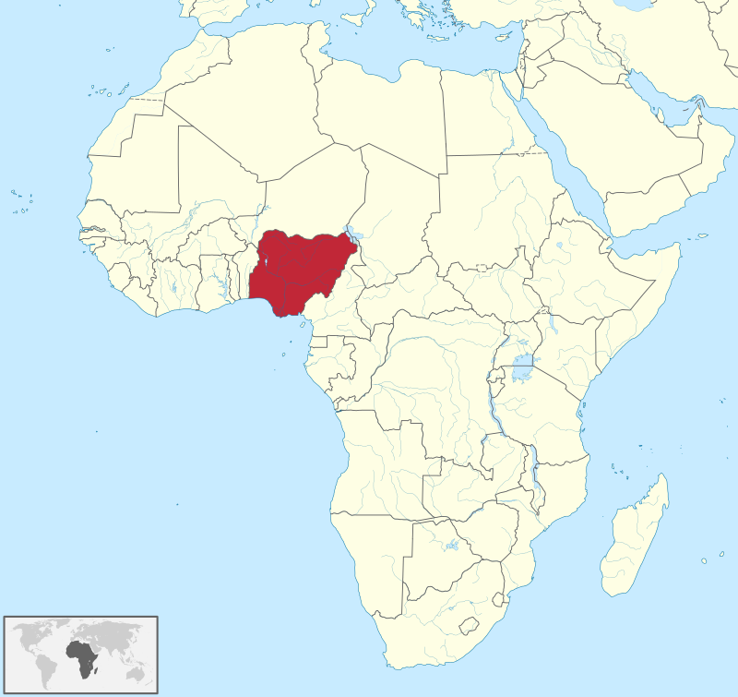
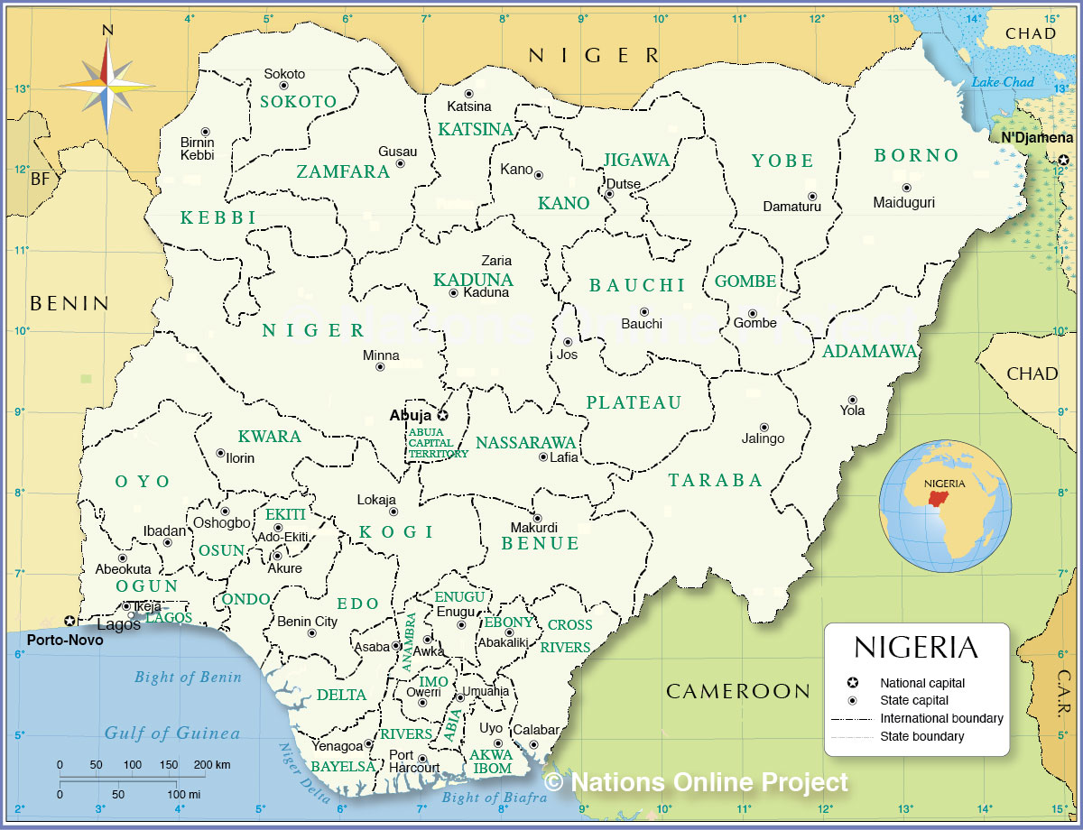
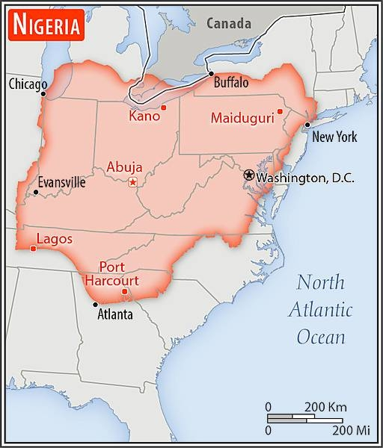

Climate
Nigeria has three distinct climate zones; a tropical monsoon in the south, a tropical savannah for most central regions, and a Sahelian hot and semi-arid climate in the north. This causes a decline in the amount of precipitation in the South versus the North. The South has a lot of rainfall from March to October with annual amounts usually above 2,000 mm. The central regions have a definite rainy season from April to September and a dry season from December to March. Coastal areas experience a shorter dry season with most rain falling between March and October. The remainder of the year is hot and dry. Nigeria’s most significant temperature change is between coastal areas and the inland, as well as the plateau and lowlands. The mean Nigerian temperature is 26.9 degrees Celsius.

Social Institutions
Family
There are three different levels of Nigerian families: lineage (ancestors), clan (living relatives), and community (tribe). All community members are responsible for each other and play an important role in the upbringing of a child. Women are responsible for household duties and are also responsible for bearing children as their primary duty. Women will still continue to help financially on the side as they partake in cooking and other crafts to add to the income of the household. When women are married they leave school, which plays a major role in the difficulty of breaking the cycle of traditional roles in women. Spouses are normally chosen by adult figures or in arranged marriages. However, many of the Nigerian youth have broken that tradition and decided to choose their own spouse and choose to live with the nuclear family unit away from village life.

Education
Education in Nigeria has developed over the years after its initial introduction by Christian missionaries as it is one of the major sectors in Nigeria which contributes towards nation-building and economic growth.
Basic Education provides formal education training to children aged between 0-15 years. The sub-levels of basic education are early child care and development education (0-4 years old), pre-primary education (1-year duration, 5 years old), primary education (6-12 years old), and junior secondary education (12-15 years old). English is the official language of instruction at the basic education level, but the language can vary depending on the location. Schools use the national policy on education guidelines to decipher the curriculum and subjects to teach their students. Certificates are given to students who successfully complete primary education to progress to the junior secondary school level.
Senior Secondary School Education prepares students to have vocational skills apart from their formal education training. Some of these skills include hair styling, crafting, and fashion design. The formal curriculum offers core subjects like mathematics, English, civic studies, and entrepreneurship along with science, arts, technology, and business. In order for these students to go on to the tertiary level of education, they need to pass the senior school certificate examination that is prepared by the West African examination council (WAEC) and national examination council (NECO). These exams are typically taken every year in May.
Tertiary education requires students to get admission into a Nigerian university by passing both examinations on top of the unified tertiary matriculation exam (UTME). Nigerian tertiary education covers universities, polytechnics, and colleges of education. The National University Commission regulates the activities of accredited universities in Nigeria. The curriculum is structured to prepare university graduates to contribute towards national development and to develop entrepreneurs to create employment opportunities. Colleges of education are also seen as training centers for the teaching profession. The teaching of polytechnics provides specialized technical education and training, along with skill acquisition for students so that they have the opportunity to contribute to the industrial and economic developments in Nigeria.
As of September 2022, it is estimated that the current illiteracy rate of Nigerians stands at 31%. This is a significant reduction from previous years, with the illiteracy level being at 38% in 2015. The graph below shows the highest and lowest illiteracy rates by zone in Nigeria, along with what percentage of genders are literate in each zone. It is evident that the highest literacy rates were registered in the country's southern regions and across all regions, that there are more literate men than women.
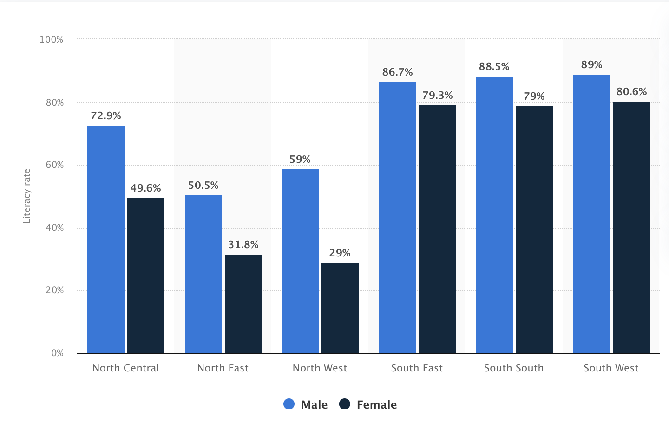

Political System
In Nigeria, there are 36 states and there are three branches of government: executive, legislative, and judiciary. The political structure is traditional where the President is elected and can not serve more than two four-year terms along with there being a Senate and House of Representatives, as well as a Supreme Court. There are 8 political parties in Nigeria and they are the All Nigeria People's Party (ANPP), the All Progressives Grand Alliance (APGA), the Alliance for Democracy (AD), the National Democratic Party (NDP), the People's Democratic Party (PDP), the People's Redemption Party (PRP), the People's Salvation Party (PSP), and the United Nigeria People's Party (UNPP).
Nigeria is currently facing a weakening economy, rising insecurity, and violent conflicts that are threatening its democratic development. This is creating distrust in the government and its institutions as the economy and democracy have grown so much in recent years and now citizens are becoming fearful that progress will be lost. The image below shows data for Nigeria from 1996 to 2021 of the political stability index, which has had an average value of -1.81. In 2021, the latest value was measured at -1.78.
In terms of current power, The People’s Democratic Party is the ruling political party currently in Nigeria with 223 seats in the House of Representatives and 76 seats in the Senate. The current President of Nigeria is Muhammadu Buhari.

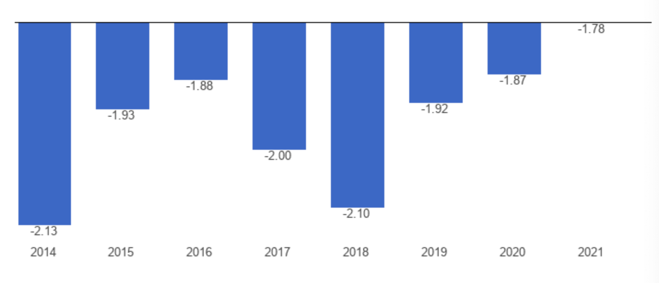

Legal System
Nigeria has a mixed legal system meaning that they use both English common law and Sharia, and customary law. They also have copyright laws, patents, trademarks, and industrial design laws. However, Nigeria does not have counterfeiting or product piracy laws which really has a huge negative impact on many businesses within Nigeria. This hurts their businesses and many countries believe that they need to change these laws. They do have intellectual property rights which are stated above.

Social Organizations
Before 1990, the country was 70% farmers and that was the majority of the social class but after 1990, Western styles of living became a new way of life for the people of Nigeria. In Nigeria, there are three levels of social class: lower, middle, and upper. The lower class worked as pottery or iron workers, the middle class had traditional jobs, and the upper class or known as “elites” typically had government jobs. The middle-class threshold for Nigeria is estimated by expenditures associated with a 10% probability of falling into poverty. Thus, the threshold expenditure for the middle class in Nigeria is found to be 378.39 Naira per capita per day (2010 PPP).” It is very hard for classes to intermingle in Nigeria because of the huge differences between classes. It is also hard to intermarry in Nigeria.
The most prominent ethnic groups in Nigeria (as of 2018) were 30% Hausa, 15.5% Yoruba, and 24.7% other. The ethnic groups with the least amount of distribution are Ijaw/Izon (1.8%) and Ibibio (1.8%).
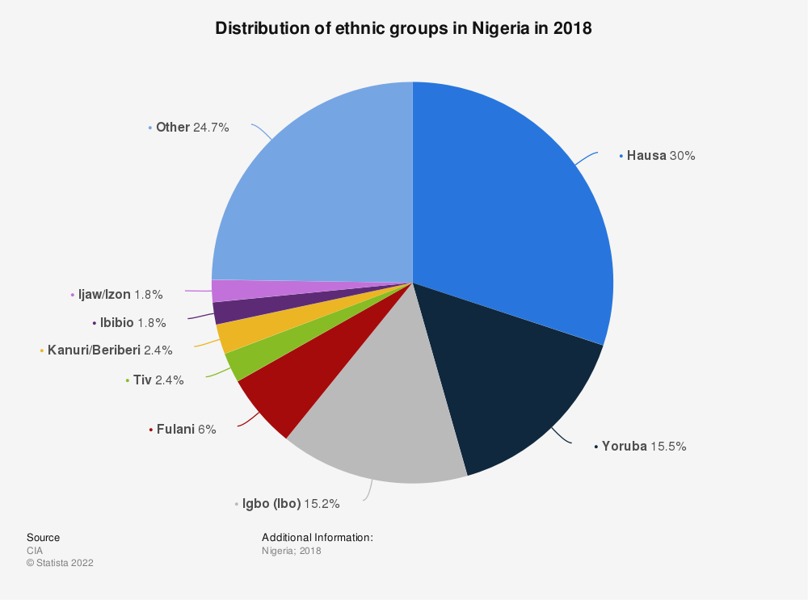

Trust is highly sought after in initial introductions in the Nigerian business world in order to establish connections and contacts. During a first business meeting in Nigeria, it is recommended that it is led with a cordial handshake and that hierarchical rules are acknowledged. A business card should always be in an accessible spot as well. It is not uncommon for little time to be spent between two business parties if it is felt the relationship will not be mutually beneficial or is not trusted. Meetings and communications are preferred to be had in person as this is believed to be the most efficient way to vet a potential business partner and assess professionalism. Meetings should be kept professional and respectful. An executive could take a break or incoming call during a first meeting, and this is not to be viewed as rude or unprofessional but rather commonplace (unlike in American business). Additionally, valuable business discussions could occur in informal conversations. Nigerian business professionals are also very casual about meeting times and it is rare that a set meeting time will remain permanent so it is essential to remain flexible with timing and expect things to change. Most importantly, trust is one of the most important elements in Nigerian business practice. It is critical that a lot of time is vetting people in the local business community and ensuring that these relationships are credible.

Religion and Aesthetics
Religion
The most prominent religious group in Nigeria is Muslim, followed by Roman Catholic, and other Christian denominations. Approximately 53.5% of the population is Muslim, 35.3% is “other Christian,” 10.6% is Roman Catholic, and 0.6% is defined as “other.”
Muslims are found everywhere in Nigeria, with a strong dominance among the Hausa and the Yoruba whereas Christianity is more prevalent in southern Nigeria. The majority of Igo and Yorubas are Christan. Conflicts between the two groups during colonial times created several breakaway African-Christian churches, with most adhering to the doctrines of Western churches but introducing African music and tradition to their Masses.
Relationships between the two groups have always been tense and neither is completely free from the influence of indigenous religions despite their dominance. Since many people who consider themselves either Muslim or Christian also identify with local faiths, this creates shortcomings in their faith and practice. Therefore, in everyday life, the majority of Nigerians follow the teachings of purely indigenous religions. Most of these religions share the idea that one supreme God created the Earth and its people, but left the people to decide their own paths in life. This means that very few Christians and Muslims implement the practices of their faith in their everyday lives due to the cultural dominance of their local heritage and instead choose to follow those practices.
However, it is important to acknowledge since such a vast majority of the population does identify as Muslim or Catholic, dietary restrictions associated with the traditions of the religion could affect sales during certain points of the year. This will also depend on how seriously individuals practice the faith, meaning whether or not they engage in all the traditions and customs associated with each religion to their full extremities. For example, Muslims could make fewer food purchases during Ramadan which occurs in the ninth month of the Islamic calendar or Catholics might purchase fewer “indulging” foods during Lent depending on what they have “given up.”

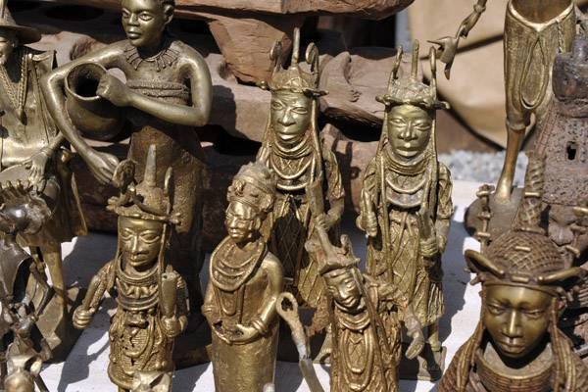
Aesthetics and Arts

The earliest and longest-standing visual art in Nigeria is sculptures. The sculptures normally depicted full-body individuals, heads, and busts. Sculptures found in Nigeria help historians and social scientists understand the Nok society in many different ways. Women were always depicted in these sculptures with jewelry and skirts with no tops. Some of these sculptures included humans with animal features which social scientists believe to have been a representation of the spread of diseases. The materials used in the sculptures are also helpful to understand settlement and migration patterns in Nigeria.
Music is a very important part of Nigerian culture and there are many different types of songs and music genres for all different types of celebrations. The Royals of Nigeria have specific and individualized songs that are forbidden to be played in honor of someone else. Highlife is an extremely popular genre of music and has risen to popularity since a Ghanaian music group went on tour in West Africa. Nigeria has solely created and popularized Ju Ju, a type of music that uses different combinations of percussion instruments and drums.
Nigerian folk tales are epic stories that explain the world around us. These stories and myths have been told for generations. They include proverbs, myths, “just so” stories, and riddles. “Just So” stories are designed to explain features of an animal, such as its appearance or its habits. Morals are either explicitly stated at the end of Nigerian folk tales, or hidden within the text. Animals, especially the tortoise, hold prominence in the tales from Nigeria. The main national symbol is the country’s flag. The green part of the flag represents agriculture, whereas the white stands for unity and peace. Other national symbols include the national coat of arms, the national anthem, the National Pledge, and Nigeria’s national motto: Peace and Unity, Strength and Progress.

Living Conditions
Diet and Nutrition
Nigerians tend to primarily consume yams, cassava (a starchy root), plantains, and rice. Common dishes include pounded yam (similar to mashed potatoes), jollof rice (rice cooked with tomatoes, peppers, and meat), and okra. Meals are usually paired with a sauce made from fish, meat, or chicken. Warmer Nigerian climates are able to produce an array of fruits and vegetables to enhance their cuisine. Nigerians also tend to “fry” many of the common foods they consume on a daily basis, with Àkàrà (Fried Bean Cake) and Puff-Puff (Fried Sweet Dough Ball) being two popular fried meals consumed regularly.
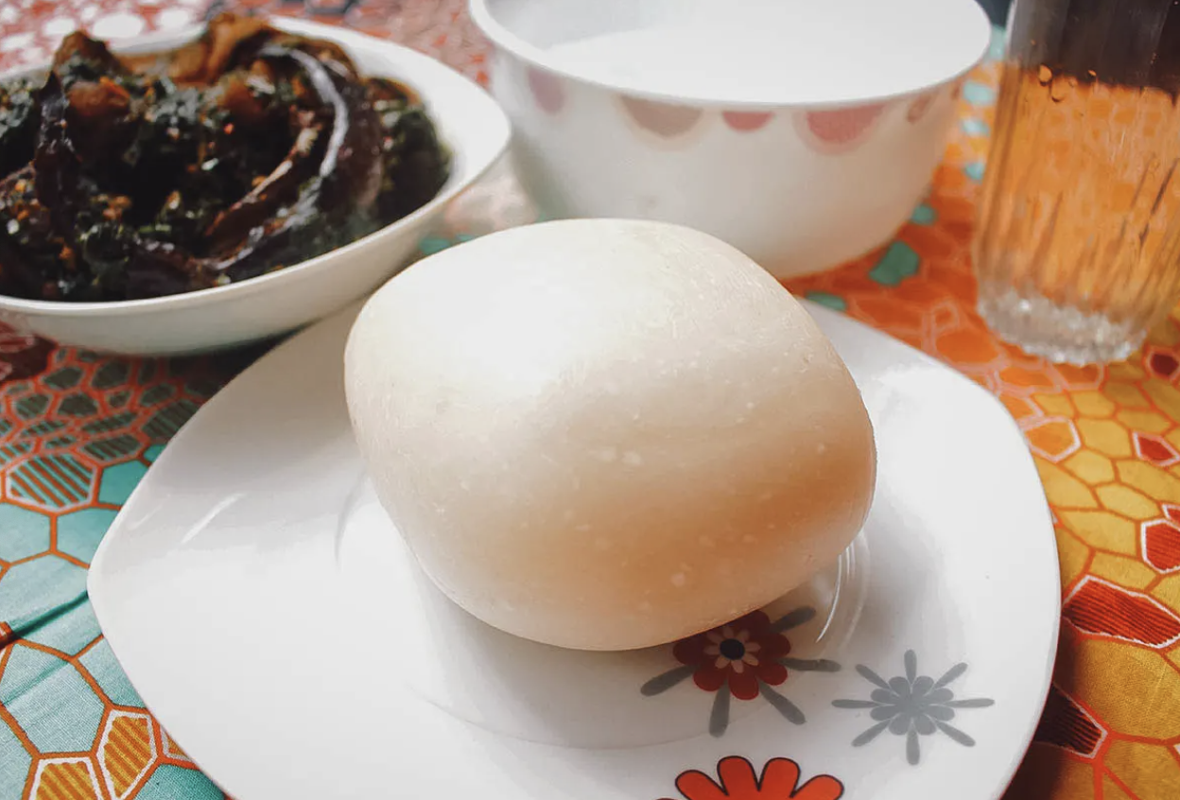
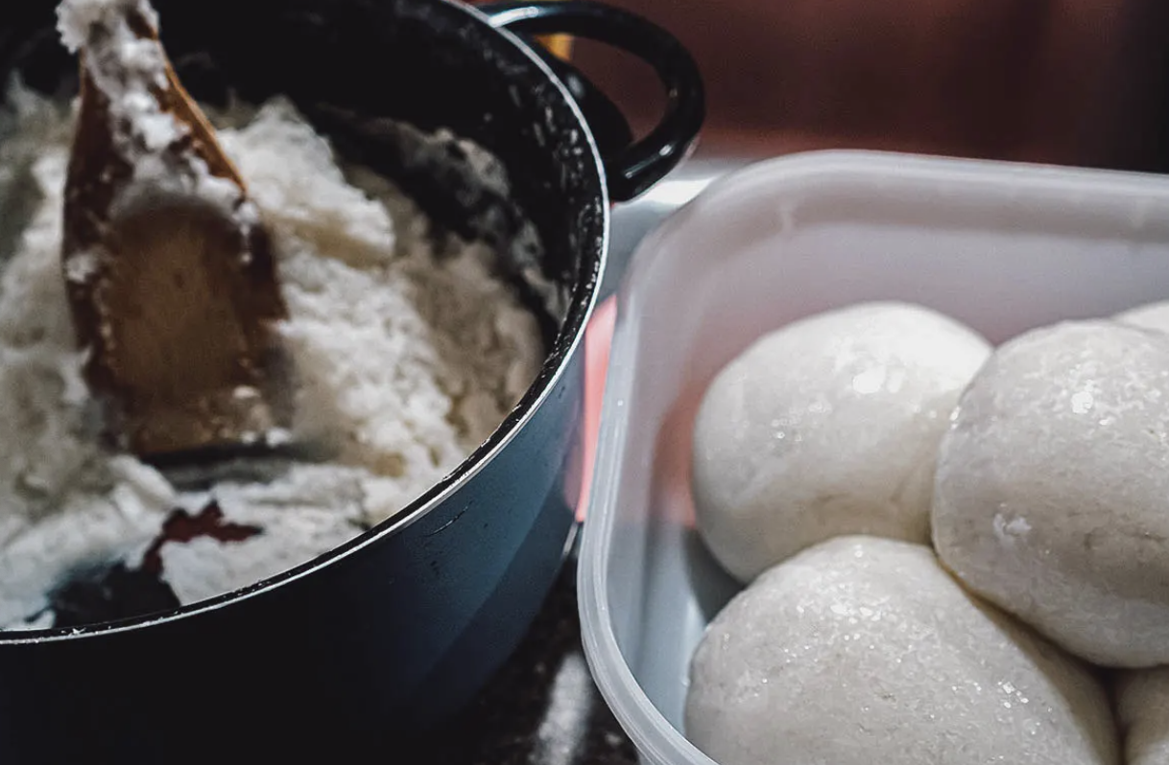
However, about two in five Nigerian children are stunted by malnutrition with rates varying throughout the country. About 30% of Nigerian children are underweight (do not meet the proper weight for their age) and this number has steadily increased over the past decade, rising from 11% in 2003 to 18% in 2013. Sadly, each year, about one million Nigerian children die before their fifth birthday meaning malnutrition contributes to nearly half of all deaths.

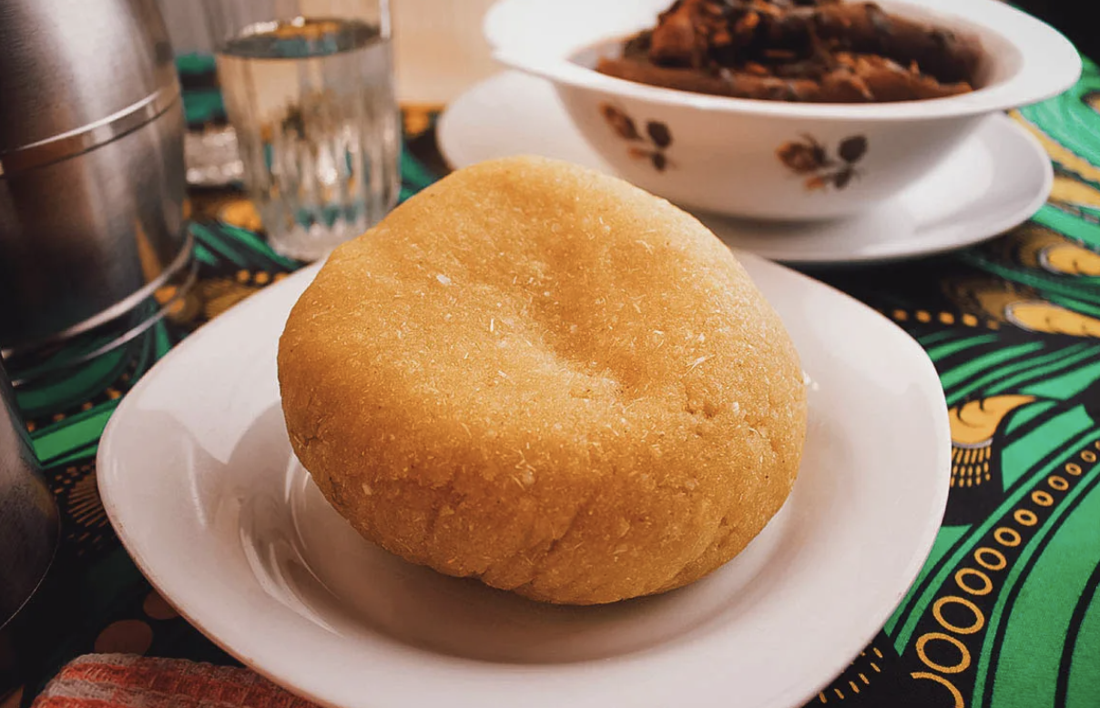

Housing
Nigerian housing is not a high priority for social spending and state governments have tended to rely upon local authorities to meet the problem. There are few efforts put into low-cost rural housing, in spite of the creation of the Federal Mortgage Bank of Nigeria in 1977 so shantytowns and slums are very common in urban areas. Overcrowding in urban housing is a serious problem, with 85% of the urban population living in single rooms, usually with eight to twelve people per room. At one point, only about 27% of Nigerian urban households had access to piped water and less than 10% had access to an indoor toilet. This emphasizes that the majority of the living conditions are poor quality. There are urban and suburban areas that include nicer quality and more spacious homes, including
- Bungalows: small houses, or cottages that is a single-story or second-story homes built with a sloping roof
- Mansions: luxury homes built on a large plot of land, up to 5,000 square feet.
- Flats or Apartments: These are the most populated homes in Nigeria and are self-contained housing units that occupy only part of a building, generally a single story.
- Terrace Duplex: This is a row of similar houses joined together by their sidewalls. These can also be called townhouses and are usually built two or three floors up.
- Semi-Detached Duplex: These Nigerian homes are a pair of duplexes built side by side sharing a common wall. Semi-detached differs from the terrace because the terrace shares a wall on both sides except for the corner piece.
- Detached Duplex: This is a standalone duplex in Nigeria and it does not share a wall with another building.
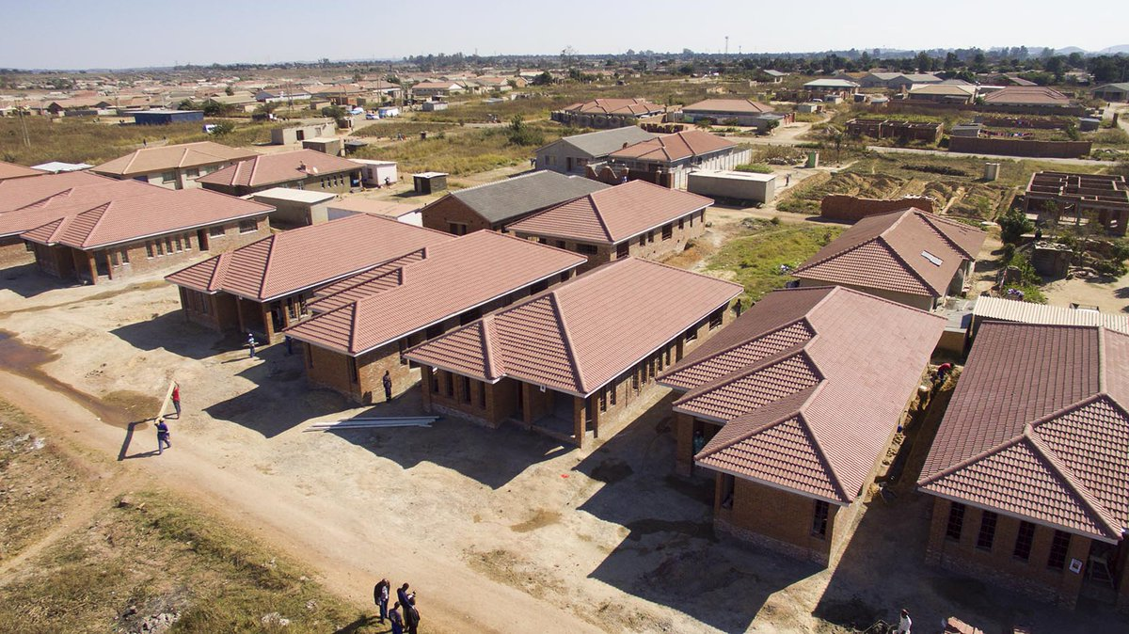
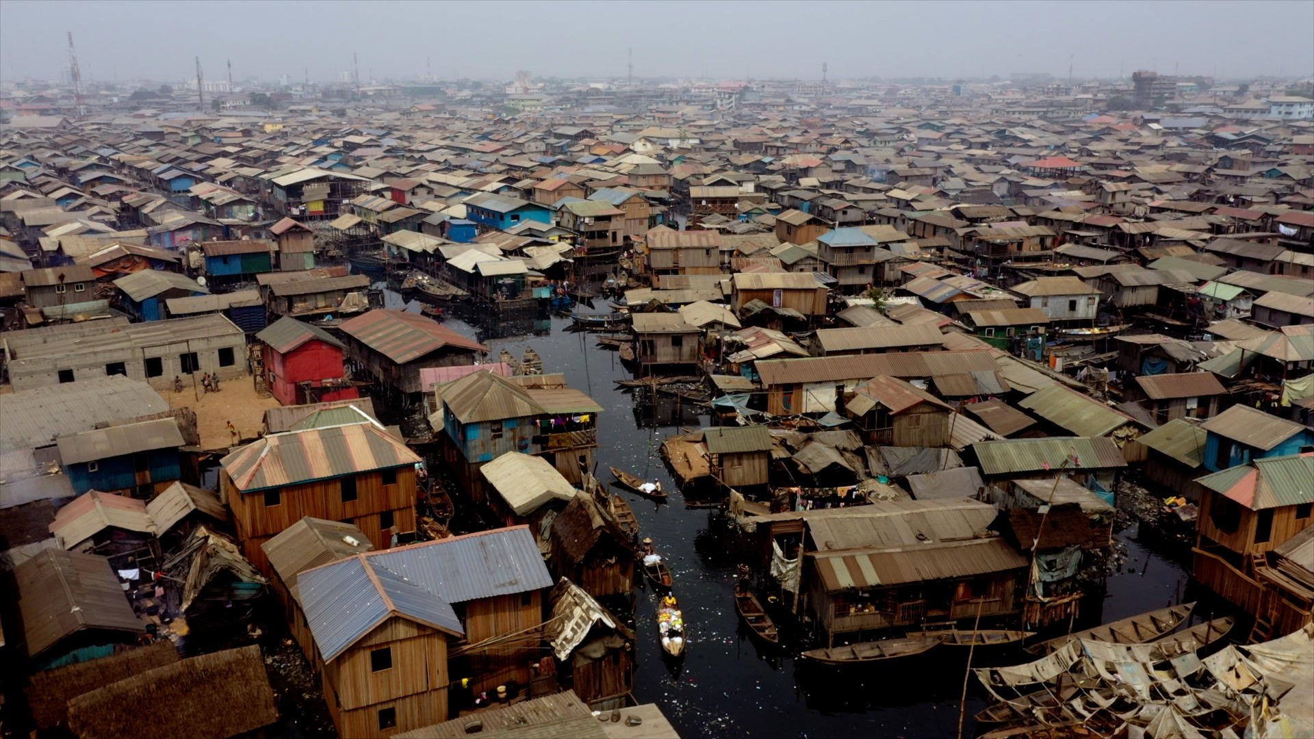



Clothing
The clothing traditions in Nigeria vary by region due to its abundant population. Some traditional dresses go back to ancient tribes whereas others were formed by the influence of British, Portuguese, and French colonizers. Clothes worn today are mostly modern, western styles but many Nigerians still prefer to wear traditional clothing in everyday life. The biggest ethnic groups in Nigeria are the Yoruba, Igbo, and Hausa-Fulani which each have their own national dress. The Yoruba people like bright colors and outstanding garments particularly at events like weddings or funerals. Items they wear include a Buba, iro, agbada, Sokoto, and gele. The Igbo people include various wraps for women and they are used in everyday life or for formal occasions. Igbo men wear cotton wrappers, shirts, and sandals. They are either worn for everyday usage or for special holidays. For both men and women, the fabric used to make everyday clothing versus those for special education varies in quality. The Hausa-Fulani people wear wide-sleeved robes called “babban riga” which is equivalent to Yoruba’s agbada. This is a popular garment among Nigerian men for formal occasions. Women wear wrappers called “abayas” or headwraps with matching blouses.
In the workplace, it is important to dress well as the way someone is dressed will signal their level of importance. With that being said, men are expected to wear dark suits and ties and women should wear dark, modest business-style suits.
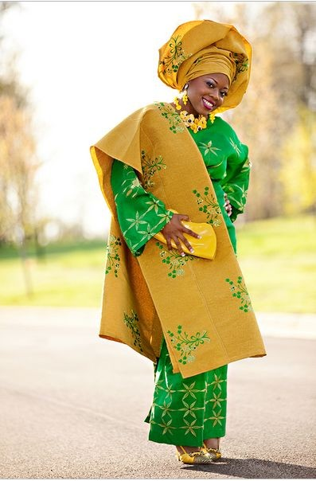
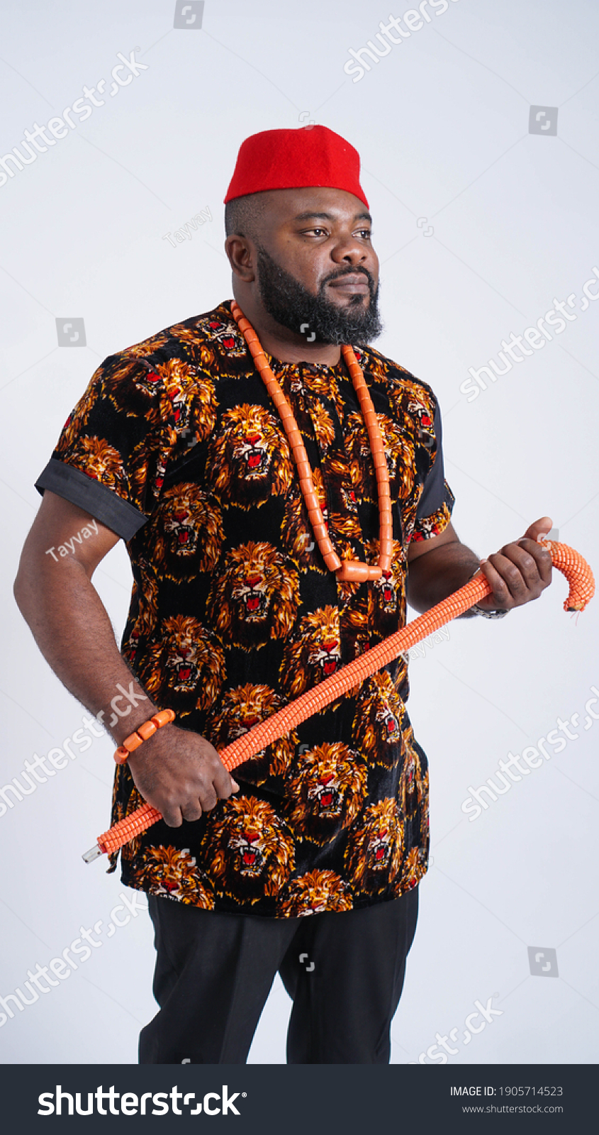



Recreation, Sports, and Leisure Available
There are a handful of sports offered in Nigeria but the five most popular ones are soccer, basketball, “dambe”(pictured below), track and field, and boxing. Soccer is the most followed and popular sport in Nigeria. It was introduced during the British colonial period and quickly spread all over the world. The Nigeria soccer team, nicknamed the Super Eagles, has given the country some of its most memorable moments. Basketball has been played in Nigeria since the 1950s and the country’s national team joined FIBA in 1964. The male team is called D’Tigers and the female team is called D’Tigress. “Dambe” is a martial art steeped in the tradition of the Hausa people, which is one of the largest ethnic groups in Africa. The popularity of the sport is growing, but could definitely grow more, as the country’s attempt to establish a national league got interrupted by the pandemic. Track and field athletics are widely practiced throughout the country, as the country is represented by some of the world’s most promising athletes like Ese Brume, Tobi Amusan, and Chukwuebuka Enekwechi. Professional boxing was considered the most popular sport in Nigeria in the 1950s and 60s but then experienced a steady decline. It was then rekindled in the 2000s. Currently, there are about 300 professional boxers in Nigeria. Overall, the national sports budget is NGN 81.14 billion ($197 million).
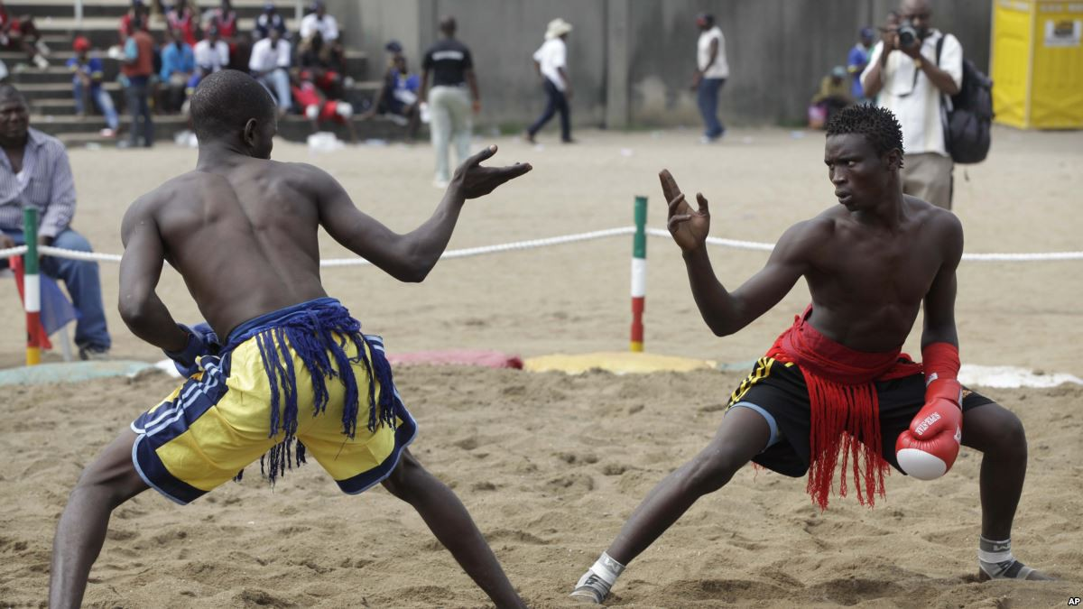

Prominent celebrities or athletes who participate in these activities and sports include Chioma Ajunwa, a former Nigerian track, and field athlete and soccer player, notable for becoming the first Nigerian to win gold at the 1966 Summer Olympics in Atlanta, and the first black African woman to win an Olympic gold medal in a field event. Nwankwo Kanu and Jay-Jay Okocha also won the Olympic gold medal in soccer in Atlanta in 1996. Hakeem Olajuwon became one of the NBA superstars in the 1990s. Ese Brume is a long jumper, three-time African Champion, and Bronze medalist at the 2016 World Championships. Tobi Amusan is a 100-meter hurdles runner and sprinter who is a two-time African Games champion. Chukwuebuka Enekwechi is a thrower and a 2018 Commonwealth Games Silver medalist and African Champion in the shot put. Nigeria had three world champions in boxing: Dick Tiger, Hogan “Kid” Bassey, and Bash Ali.

Healthcare
The healthcare system in Nigeria is not developed or supported with only 49% of Nigerians having access to healthcare within five kilometers of their home and the doctor-to-patient ratio being one to 5,000. This shows that there are not many services available for people in Nigeria. Over half the country does not have access to healthcare. This is likely due to only 3% of the country’s GDP being invested in the health sector, which is considerably below the average spending on healthcare among OECD countries. Nigerians are usually forced to pay for medicine out of their own pocket and this medicine comes at an expensive cost. The cost is so significant that in 2019, healthcare expenditures made up 6% of Nigerian household spending, with this figure increasing in rural areas. They also have inadequate facilities and healthcare workers do not have all the resources that they need. Due to this healthcare system's instability, there is little to no information available as to what percentage of the population does have access to healthcare. The demand for personal funds to support healthcare needs and services likely deters many Nigerians from pursuing it.

Language
The official language of Nigeria is English but it is spoken less frequently in rural areas and among people with lower levels of education. Other prominent languages are Hausa, Yoruba, Igbo (Ibo), Fulani, and over 500 other additional indigenous languages.
Hausa is a Nigerian tribe that has a long history of written language which is not expected to be found among these African tribes. They use their own alphabet which was originally derived from the Arabic language. It is more common to find a community of tribes that all share a common language instead of one unified large tribe.
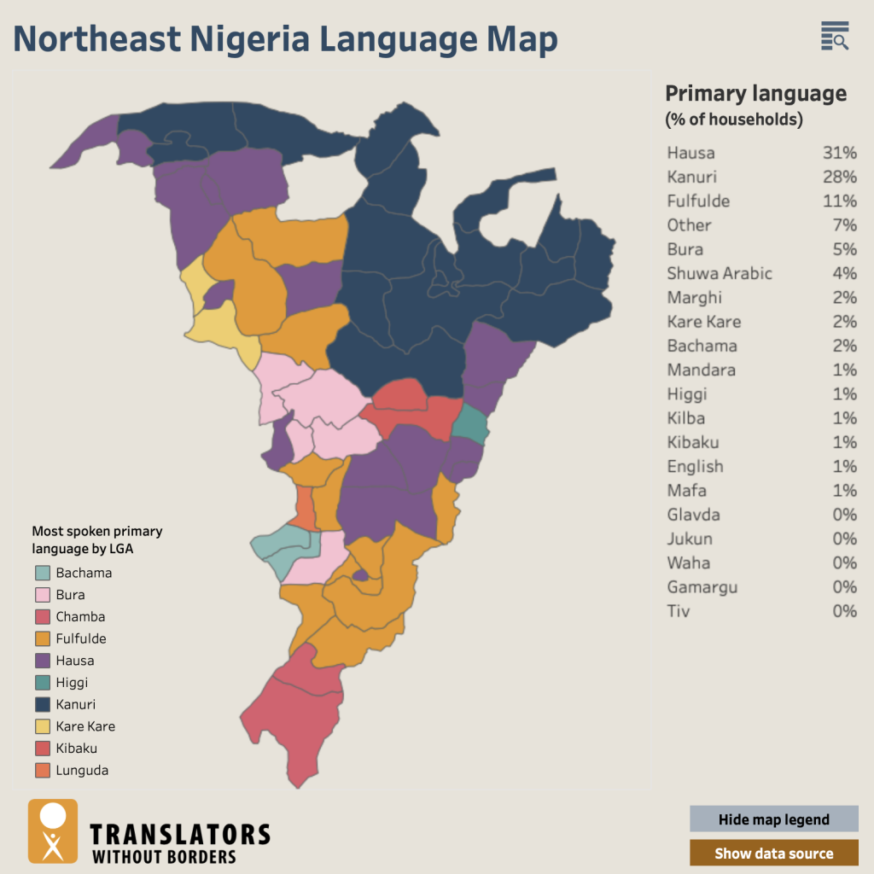
In Nigeria, there are many different dialects, over 525 to be exact. The main languages that are spoken in this country are English, Hausa, and Yoruba. The image below shows what percentage of the country speaks each language and it corresponds to the color and area of Nigeria. The official language of Nigeria is English. This country is one of the most disbursed countries in the world with a multitude of different languages and dialects that are spoken.

Works Cited
AFS-USA Country Information & Resources - AFS-USA. (n.d.). Retrieved December 1, 2022, from https://www.afsusa.org/countries/
"Between hunger and the virus". Human Rights Watch. (2021, July 28). Retrieved November 30, 2022, from https://www.hrw.org/report/2021/07/28/between-hunger-and-virus/impact-covid-19-pandemic-people-living-poverty-lagos
Business etiquette in Nigeria (norms, social cues, and customs). KPA. (2022, September 14). Retrieved November 30, 2022, from https://kpakpakpa.com/business-etiquette-in-nigeria/
The Colonial Era (1882-1960). Religion and Public Life at Harvard Divinity School. (n.d.). Retrieved November 30, 2022, from https://rpl.hds.harvard.edu/religion-context/country-profiles/nigeria/colonial-era-1882-1960
Encyclopædia Britannica, inc. (n.d.). Climate of Nigeria. Encyclopædia Britannica. Retrieved November 30, 2022, from https://www.britannica.com/place/Nigeria/Climate
FutureLearn. (2021, August 11). Explore: Education in Nigeria. FutureLearn. Retrieved November 30, 2022, from https://www.futurelearn.com/info/futurelearn-international/explore-education-in-nigeria#:~:text=
“Iggy's Doughboys, Chowder House & Creamery.” Iggy's → A Rhode Island Tradition, 31 Jan. 2022, https://iggysri.com/.
Language data for Nigeria. Translators without Borders. (2022, July 6). Retrieved November 30, 2022, from https://translatorswithoutborders.org/language-data-nigeria
Malnutrition: Nigeria’s silent crisis - prb.org. (n.d.). Retrieved December 1, 2022, from https://www.prb.org/wp-content/uploads/2015/07/nigeria-malnutrition-factsheet-1.pdf
Nigerian Culture, http://ng.china-embassy.gov.cn/eng/zngx/whjl/CulturalExchanges/.
Nigerian dress code. World Business Culture. (2021, January 24). Retrieved November 30, 2022, from https://www.worldbusinessculture.com/country-profiles/nigeria/business-dress-style/
Nigerian Folk Tales. FairyTalez. (n.d.). Retrieved November 30, 2022, from https://fairytalez.com/region/nigerian/
The Colonial Era (1882-1960). Religion and Public Life at Harvard Divinity School. (n.d.). Retrieved November 30, 2022, from https://rpl.hds.harvard.edu/religion-context/country-profiles/nigeria/colonial-era-1882-1960
“World Bank Climate Change Knowledge Portal.” Climatology | Climate Change Knowledge Portal, https://climateknowledgeportal.worldbank.org/country/nigeria/climate-data-historical#:~:text=Nigeria%20is%20characterized%20by%20three,amounts%20from%20south%20to%20north.
What is healthcare in Niger like? CountryReports. (n.d.). Retrieved November 30, 2022, from https://www.countryreports.org/country/Niger/health.htm.

Economic Analysis
Population
Total Population
Nigeria has the highest population of any African nation and the population is only expected to grow to 392 million people in 2050, compared to 186 people in 2016. This makes Nigeria the world’s fourth most populous country. This growth will continue for the foreseeable future due to population momentum and its high birth rate. This shows that the upcoming population in Nigeria is very young. The birth rate is 34.19 births / per 1,000 population (2022 est.).

Distribution of Population
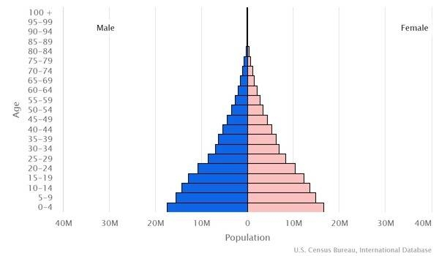
41.7% of Nigeria’s population is between the ages of 0-14 years (45,571,738 male, 43,674,769 female) and this age distribution is the most predominant. Only 3.3% of the population is over the age of 65 years (3,329,083 male, 3,733,801 female). The graph inserted below shows the 2022 population distribution for Nigeria. The percentage breakdown of the remaining population is 20.27% between 15-24 years, 30.6% between 25-54 years, and 4.13% between 55-64 years. The median age range is 18.6 years for females and males.

Gender
The gender Demographic within Nigeria is 1,026 males to 1,000 females. This gender distribution means that Nigeria’s sex ratio is higher than the global sex ratio. In total for 2022, there are approximately 110,858,809 males in Nigeria and 108,064,427 females in the country. (This number varies by the second due to births and deaths). In addition, within the country males make up 50.6% of the population, whereas females make up 49.4%. This shows that Nigeria is split almost evenly between men and women.

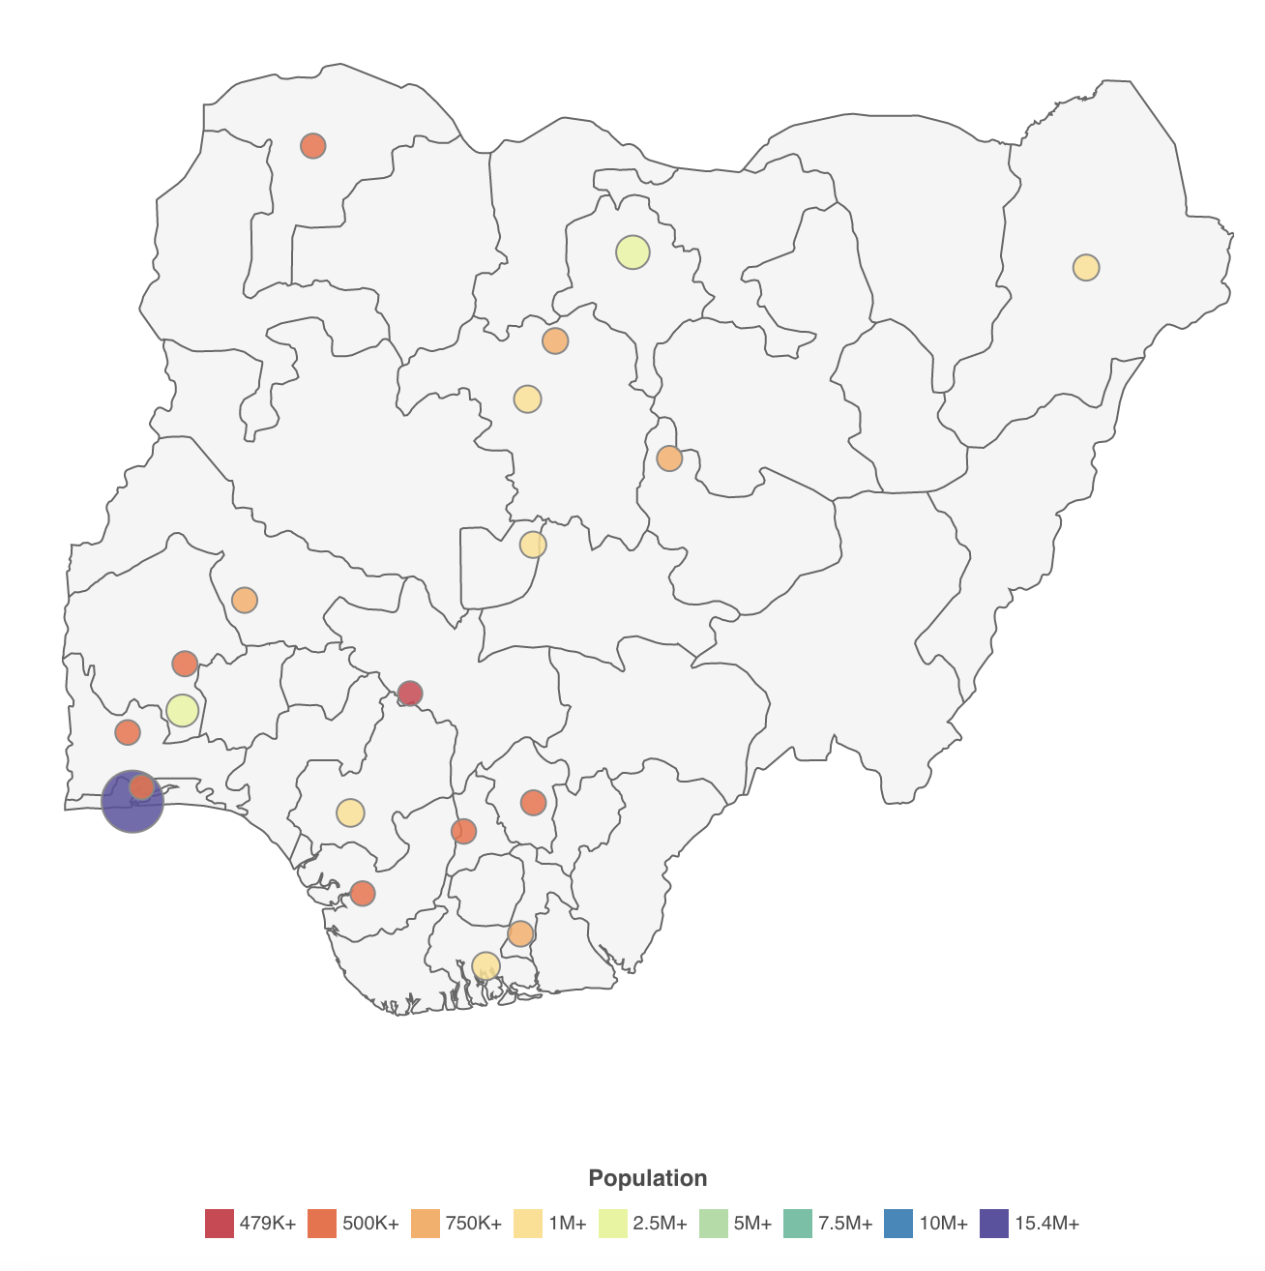
Geographic Areas of Population
Nigeria has the largest population of any African country, with much of the population living in the southern and southwestern areas. There are five cities in Niergia with a population greater than one million. Lagos’s population is the largest, totaling 15,388,000, followed by Kano, Ibadan, Benin City, and Port Harcourt. The map below shows the population distribution in Nigeria.

Migration Rates
Nigeria’s net migration rate was -0.21 migrant(s)/1,000 population (2022 est.).

Economic Statistics and Activity
Gross National Product (GNP) and Gross Domestic Product (GDP)
In 2019, Nigeria’s total GDP was $475.062 billion with the GDP per capita being $5,100 in 2019 and $4,900 in 2020. The line graph below shows Nigeria’s GDP over the last 10 years (2011-2021). In 2017, the real GDP growth rate was 0.8% compared to -1.6% in 2016. In 2015, the growth rate was 2.7%. This shows that the real GDP growth rate has been inconsistent on a yearly basis. The Purchasing Power Parity (PPP) is the rate at which one currency would need to be exchanged to have purchasing power as another currency. In 2020, the PPP was estimated at $1,013,530,000,000 compared to $1,032,050,000,000 in 2019. In 2018, the PPP was valued at $1,009,750,000,000. The Gross National Income was $2,100 in 2021 which was a 5% increase from $2,000 in 2020.

Distribution of Wealth
In Nigeria, there is an upper class, an upper-middle-class ($10-$20 per person/day), a lower-middle-class ($4-$10 per person/day), a “floating” class ($2-$4 per person/day), and people below the poverty line (<$2 per person/day). Nigeria’s unequal proportion of the population in each income class for 2022 has 15.5% of the total population in the bottom 50%, 41.8% of the population in the middle 40%, 42.7% of the population in the top 10%, and finally 11.6% of the population in the top 1%.
Therefore, the wealth by percent seems to be disproportionate but the numeral value of income does not seem to vary much between similar classes. This shows that even a slight difference in the dollar amount being brought home each day can significantly alter the quality of life for Nigerian people.
Finally, the Gini coefficient represents the degree of inequality within a family in a country. Inequality is shown by how far the Lorenz curve is from the 45-degree line which would equal a higher Gini calculation. Therefore, Nigeria’s calculations are 35.1 in 2018 est, and 50.6 in 1997, meaning this is trending towards more equality. Some of the natural resources in Nigeria are natural gas, petroleum, tin, iron ore, coal, limestone, coal, limestone, niobium, lead, zinc, and arable land.

Surface Transportation
Nigeria has a wide variety of transportation modes for citizens and visitors to use. The country has the ability for plane and helicopter travel via airports and heliports, along with pipelines, railways, roadways, waterways, merchant marine ports, and ports and terminals. These are widely available to consumers with countless forms actually contributing to the country's GDP.

Usage Rates
To understand the usage rates for different modes in Nigeria it can be useful to look at the usage rates and transportation statistics in the United States. It is clear that residents of the United States depend heavily on cars for transportation. 76% of Americans use their car to commute between home and work, 11% use public transportation, and only 10% use a bike. In Nigeria, the most commonly used mode of transportation is also roads. Roads hold more than 80% of the accumulated traffic in the entire country. However, despite the popularity of traveling on the road system, it can be dangerous. There has been clear neglect of infrastructure in Nigeria, which is translated into the dangerous conditions of the roads in some areas. Many citizens recommend avoiding public transportation for this very reason. The vehicles are not equipped for the road conditions and drivers can be reckless as well.

Ports and Transportation
Nigeria’s major seaports are the Bonny Island Terminal, Calabar, and Lagos. They have six major oil terminals, named the Bonny Terminal, the Brass Terminal, the Escravos Terminal, the Forcados Terminal, the Pennington Terminal, and the Qua Iboe Terminal. Finally, they have 8,600 km of river waterways in the country. This consists of the Niger and Benue Rivers and small rivers and creeks.
Nigeria has a total of 54 airports, with 40 of them having paved runways and the remaining 14 runways being unpaved. The most common paved runway length is 2,438 to 3,047 m, with only 3 being under 914 m. Most unpaved runways are significantly smaller, falling between 914 to 1,523 m and non-exceeding 2,437 m.

Communication Services
The communication that is available to the people of Nigeria is fixed line telephones, cellular telephones, and broadcast media. To compare the usage rates of each of these communication services, the given rates were compared to those of the United States to get a better understanding. In Nigeria, there are 107,023 telephone fixed-line users. In comparison, to the United States, on the list of countries Nigeria is number 135 to the United States which is number two. For the usage of mobile cellular telephones around 204,228,678 people subscribe to this type of communication service. Compared to the world's users, Nigeria is number seven and the United States is number two. For the usage of broadcast media, most of the stations are government owned therefore the government puts on what they want the people to see. 70% is government owned and 20% is not.

Principle Industries
Nigeria is an emerging and growing economy. There are several industries that contribute to the steady growth of the economy. These industries are banking, agriculture, real estate/construction, consumer goods, healthcare, information, and communications technology, oil and gas, entertainment, tourism, and utilities. All of the industries listed above are broad examples of the main industries in Nigeria. Some of the products within the industries that are focused in Nigeria include crude oil, coal, tin, columbite, rubber products, wood, hides and skin, textiles, cement, and other construction materials, food products, footwear, chemicals, fertilizer, printing, ceramics, and steel.
The services sector which includes information and communications is the largest proportion of Nigeria’s total GDP accounting for 54.39%, the agricultural industry accounts for 21.96% of Nigeria’s GDP, the oil sector is the largest revenue stream for the nation’s government and is the most frequent export out of the country, the oil industry accounts for around 5.87% of Nigeria’s GDP. Information regarding the ratio of public to privately owned industries is not available.

International Trade Statistics
The top exports of Nigeria are Crude Petroleum ($30 billion), Petroleum Gas ($5.89 billion), Scrap Vessels ($1.29 billion), Special Purpose Ships ($775 million), and refined Petroleum ($613 million). Exports from Nigeria fell by 11.9% year-on-year to a nine-month low of NGN 1,795 billion in September 2022. This was due to lower shipments of crude oil (-6.9%), manufactured products (-79.1%), energy products (-86.4%), and solid minerals (-37.1%). On the other hand, overseas sales grew for other products such as oil products (24%) and agricultural goods (14.4%). The graph below shows the summary of export trends for Nigeria over the past 10 years. The graph clearly demonstrates that exports have tended to be relatively stable and then rapidly decline, but have always proven to increase in the future.
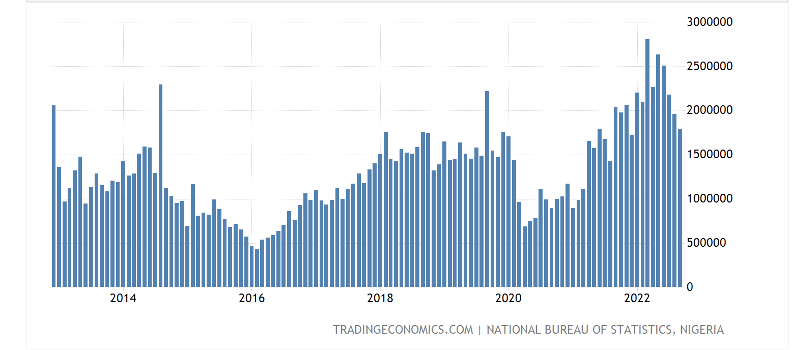
The top imports of Nigeria are Refined Petroleum ($7.75 billion), Cars ($3.30 billion), Wheat ($2.15 billion), Packaged Medicaments ($1.38 billion), and Telephones ($4.58 billion).
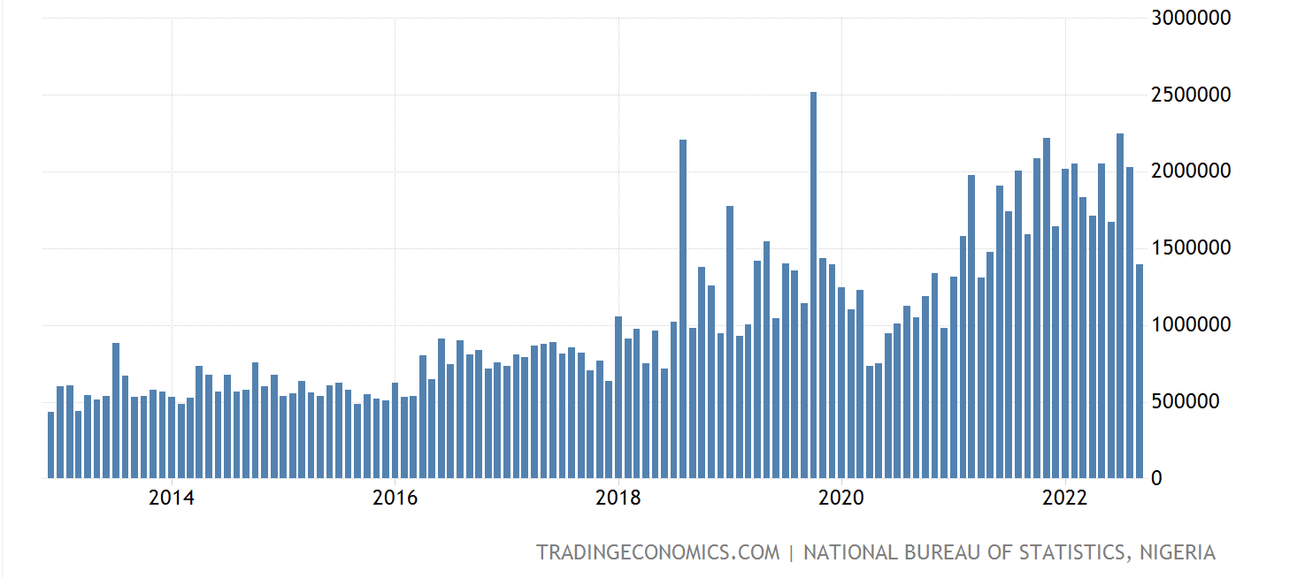
Nigerian imports fell 12.4% to a 17-month low of NGN 1,393 billion in September 2022 due to purchases in oil products (-80.5%) outweighing increases in agricultural goods (18.4%), raw materials (17.9%), and solid minerals (11.8%). The graph below shows the summary of imports into Nigeria over the past 10 years. The graph clearly shows that the number of imports has only steadily been increasing in the past five years and has only experienced a significant drop-off in recent months. This is likely due to the war between Russia and Ukraine affecting the availability of oil products.

Nigeria recorded NGN 194 trillion in foreign trade deficit in 2021, which implies a negative trade balance as the Nigerian economy remains import-driven and dependent on the exports of petroleum and some agricultural products to meet foreign exchange earnings. The first annual trade deficit in four years was recorded in 2020 when imports exceed exports by N7.37 trillion. The report showed that the total exports were N18.91 trillion while total imports were N20.84 trillion, which created a trade deficit of N1.94 trillion.
For exchange rates, $1 USD is equal to 432.353 Nigerian Naira (NGN) and 1 NGN is equal to 0.00231287 USD. Nigeria operates on a Multiple Exchange rate system. The Dual/Multiple exchange rate systems are put in place to help the economy after a recession. The system is meant to stabilize different revenue streams. However, there are many criticisms and certain downsides to this type of exchange rate system. The system can trigger black markets, manipulation for personal gain, and the instability of protection for domestic markets. The pandemic and the threat of another recession for Nigeria call into question whether or not the country will revert back to a single exchange rate system.
The Naira is currently at a record low against the USD due to pressure from dwindling foreign exchange inflows and falling oil production. As of early September, it has weakened 0.27% to $435.60, becoming the lowest value the currency has ever traded at.

Trade Restrictions
Nigeria Customs Service has completely prohibited the importation of any of the following items: air pistols, airmail photographic printing paper, all counterfeit or pirated coins of another country, bank invoices, beads composed of inflammable cloud, coupons or foreign football pools, cowries, exhausted tea, indecent or obscene prints, painting, books, engraving, or any indecent or obscene articles and matches made with white phosphorous, meat, vegetables or other provisions declared by a health officer to be unfit for human consumption, pistols disguised in any form, second-hand clothing, nuclear and other toxic waste, spirits containing more than 48 and one half per centum of pure alcohol by volume. There are currently no embargoes on Nigeria or any that Nigeria has imposed on another country.
The OPEC (Organization of Petroleum Exporting Countries) has put a new quota on petroleum production. The new quota raised the amount of production per day from August at 1.826 million barrels to 1.830 million barrels per day in September. Nigeria has been unable to meet the new quotas that the OPEC has been imposing on petroleum production, this is mainly due to the high level of oil theft within the country. It is extremely important for Nigeria to focus on the production of oil as it is one of the largest revenue streams in the country and the new quota shows just how important a larger production of petroleum is to the rest of the world.
The items that have import tariffs imposed are many luxury items. The import tariffs are important to note because all of them are above the 70% limit, therefore, being extremely important tariffs to note. Examples of luxury items that would sustain a duty or tariff are yachts, motorboats, and other vehicles for pleasure (75% tariff). Import tariffs are also on goods such as alcohol and tobacco products (75%-95% tariffs). Import taxes are also used to help grow the agricultural sector adding import tariffs to wheat (85%), sugar (75%), rice (70%), and tomato paste (50%). Nigeria has several tariffs that are enforced on products from the United States. These tariffs are meant to secure domestic profit and industries. The tariffs include zero duty on capital goods and essential drugs, a 5% duty on raw materials, 10% on intermediate goods, 20% on finished goods, and 35% on imports into strategic sectors. Nigeria is using these tariffs in an attempt to grow its agricultural sector.
Nigeria is a member of the World Trade Organization and the GATT. Nigeria also has many different investment agreements with several countries. It is clear that Nigeria is attempting to diversify and become politically powerful through trade and trade agreements.

Labor Force
Nigeria’s labor force is estimated to be 60.08 million. The distribution of this force is 70% agriculture, 10% industry, and 20% services. The unemployment rate is estimated to be 16.5% and 18.3.% with those unemployed individuals between the ages of 15 and 24 years. The US unemployment rate was 3.7% in August 2022 for comparison.
Inflation Rates
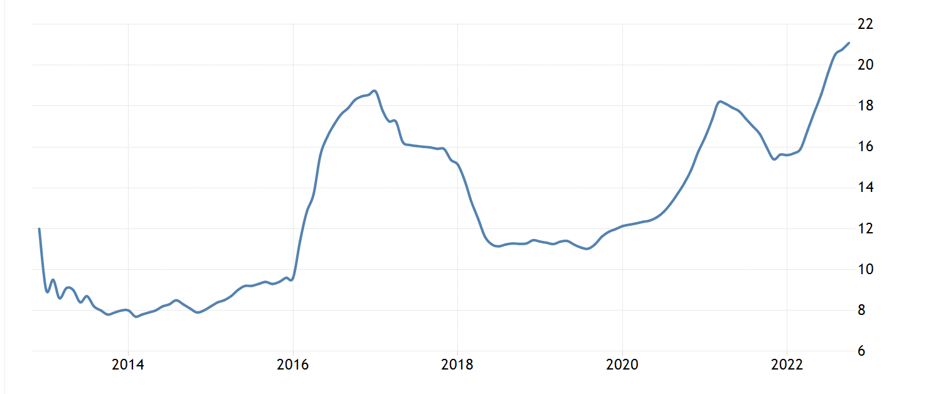
The annual inflation rate was 20.52% in August 2022 and is at its highest since September 2005. The line graph below shows Nigeria's inflation rates over the past 10 years.

Developments in Science and Technology
Current Technologies Available
Today, Nigeria still has deep access gaps, where nearly 25 million people have no access to any form of telephony services. However, through regulatory interventions and policies, the sector opened up, where some 289 million lines have been connected, of which 199 million are active.
In a survey conducted in 2020, around 18% of households in Nigeria had a computer. The majority of households owning a PC were located in urban Nigeria. In these areas, 17.3% of respondents owned a computer, while 12.8% declared that someone else in their households had one.
The same report said that, as of January 2021, Nigeria had a population of 208.8 million, and about 104.4 million were internet users, giving a mobile penetration rate of 50%. Of those, 93.3% accessed the internet via a mobile phone. Also, 33 million, or 15.8%, of the population are active social media users.

Technological skills of the labor force and the general population
Experts estimate that Nigeria’s digital sector could add $88 billion and 3 million jobs to the economy by 2027. Young people are migrating to urban areas in close proximity to new technologies, improved opportunities, and self-employment. This migration is boosting consumer expenditure. There is also increasing mobile penetration, where Nigeria is the largest mobile market in Africa, at a 61% penetration rate.
Increasing the continent's internet access to 75% can create 44 million jobs. This growth will ride on the rising smartphone penetration, payment services, and e-commerce market.
Alongside the rest of the world, they are experiencing the Fourth Industrial Revolution: Technology advancement across businesses, governance, and social interaction is influencing business operations and the ICT sector in general. Developments in artificial intelligence, machine learning, peer-to-peer platforms, and manufacturing technology are helping companies and individuals and companies access new opportunities for productivity.

Channels of Distribution
Supply Chain Issues Since the Pandemic
COVID-19 was extremely harmful to Nigeria's economy, it decreased the consumption of households, decreased the number of net exports the country partook in, and decreased the amount that people invested in. This further disrupted the supply chain because people were unable to pay for products due to businesses being shut down. Since trade decreased this also hurt the supply chain. For companies that were able to trade, COVID-19 slowed down extremely resulting in a decrease in trade within the country.

Retailers
There are more than 600,000 small shops and open-air markets in the Nigerian retail landscape. This accounts for 97% of all national sales in food, beverage, and personal care products. Nigeria is one of five African countries where the traditional retail sector remains at the core of African commerce.
There are many department stores within the Palms Shopping Mall. There are also department stores like PSC Solar UK, Mackay Boutique, Liquor Etc., and Makor. Supermarket chain stores exist in Nigeria as well, including Spar Nigeria, Shoprite, Addie Supermarket, Exclusive Supermarket, and Genesis Supermarkets.
Most of the specialty shops located in Nigeria are in Lagos. They have Classic Souvenir Store, Inside Story Gift Boutique, and The Surprise Package Company. Also, in Lekki, there is the Lekki Gift Company and the Gift Fairy NG.

Media
Availability of Media and Average Cost to Advertise
In Nigeria, the cost to advertise on TV in Nigeria depends on the channel, the length of the advertisement (ranging from 15 to 30 seconds), and whether or not the advertisement is being broadcasted during “peak” viewing times. TV is readily available in nearly all Nigerian households and is one of the most commonly used forms of media.

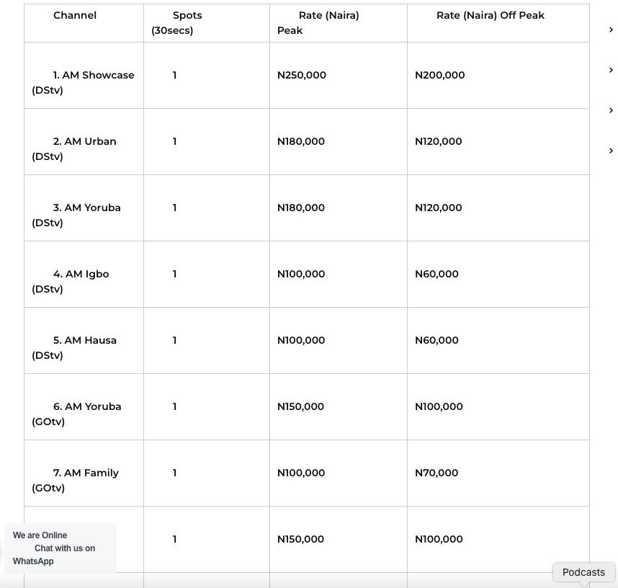

Radio is available in Nigeria and it costs between NGN 56,382 to NGN 65,000 in the peak period, and NGN 53,845 to NGN 55,000 in the non-peak period. This is the most popular and commonly used form of media in Nigeria because it is the platform most Nigerians have consistent access to.
Print media is available in Nigeria and it costs NGN 600, 000 to put in advertisements in Nigeria. The Internet is available in Nigeria, and putting an advertisement on the internet costs NGN 50,000 – NGN 300,000 per month. This is the third most common media type in Nigeria with most people having some form of access to the internet despite the varying costs. Social media is available to the people in Nigeria, to post an ad on social media would be roughly $56 USD daily.

Coverage of Various Media
According to the Broadcasting Board of Governors, most Nigerian households have a functioning television and radio. In numbers, 83.4% of households have a radio and 74.6% have a television. The statistics continue in this report with 78.4% of Nigerians reporting listening to the radio weekly. Nigerians can pay extra to access more channels and satellites with their cable television subscription or set. Although it is clear that televisions and radios are popular forms of media and have a high percentage of coverage in Nigeria, mobile phones surpass these statistics. 87% of Nigerians own a mobile phone and internet cafes are no longer a necessity to communicate with others as many households have internet access.

Percentage of Population Reached by Each of the Media
Nigerians frequently consume the news, with two-thirds saying they access the news at least once a day (66.6%). This rate is highest among men (72.8%) and those living in urban areas (72.4%). Radio is the dominant news platform with 83.4% of households having access to a working radio. TV is the second most dominant media form with 74.6% of households having a working TV but urban households are more likely to have a TV and the likelihood of a household having one is 60.6% lower among those with less than secondary education. 87% of Nigerians also claim to have mobile phone ownership, which is higher than both rates for radio and TV. There has also been a significant increase in home interest access, growing to 22.9% from 7.5% in 2012. This increase in mobile phone ownership and internet use is led by the younger and more educated Nigerian population with more than nine in 10 of those accessing these platforms regularly having completed at least secondary education. Due to this increase in personal ownership of mobile phones and internet access, internet cafes are not as necessary for communication and are slowly becoming an element of the past.

Works Cited
1. (n.d.). Nigeria - Market Overview. International Trade Administration | Trade.gov. Retrieved December 6, 2022, from https://www.trade.gov/country-commercial-guides/nigeria-market-overview
1. (n.d.). Nigeria - Prohibited and Restricted Imports. International Trade Administration | Trade.gov. Retrieved December 6, 2022, from https://www.trade.gov/country-commercial-guides/nigeria-prohibited-and-restricted-imports
Countrymeters.info. (n.d.). Nigeria Population. Countrymeters. Retrieved December 6, 2022, from https://countrymeters.info/en/Nigeria#:~:text=The%20sex%20ratio%20of%20the,1%2C000%20females%20as%20of%202021.
Izuaka, M. (2022, August 4). OPEC raises Nigeria's oil quota for September. Premium Times Nigeria. Retrieved December 6, 2022, from https://www.premiumtimesng.com/news/top-news/546776-opec-raises-nigerias-oil-quota-for-september.html
Nigeria (NGA) exports, imports, and trade partners. OEC. (n.d.). Retrieved December 6, 2022, from https://oec.world/en/profile/country/nga#:~:text=Exports%20The%20top%20exports%20of,South%20Africa%20(%242.17B).
“Nigeria ExportsNovember 2022 Data - 1981-2021 Historical - December Forecast.” Nigeria Exports - November 2022 Data - 1981-2021 Historical - December Forecast, https://tradingeconomics.com/nigeria/exports#:~:text=Exports%20in%20Nigeria%20averaged%20530660.07,Millions%20in%20February%20of%201983.
Nigeria GNI per capita 1962-2022. MacroTrends. (n.d.). Retrieved December 6, 2022, from https://www.macrotrends.net/countries/NGA/nigeria/gni-per-capita#:~:text=Nigeria%20gni%20per%20capita%20for,a%206.22%25%20decline%20from%202017.
Nigeria inflation Rate November 2022 data - 1996-2021 historical - December forecast. Nigeria Inflation Rate - November 2022 Data - 1996-2021 Historical - December Forecast. (n.d.). Retrieved December 6, 2022, from https://tradingeconomics.com/nigeria/inflation-cpi
Nigeria's Private Sector Looks Past the Pandemic. ifc.org. (n.d.). Retrieved December 6, 2022, from https://www.ifc.org/wps/wcm/connect/news_ext_content/ifc_external_corporate_site/news+and+events/news/insights/nigeria-ps-looks-past-pandemic#:~:text=Lockdowns%20and%20movement
Osae-Brown, A. (2022, September 6). Nigeria naira (NGN/USD) falls to record low against the dollar as reserves fall. Bloomberg.com. Retrieved December 6, 2022, from https://www.bloomberg.com/news/articles/2022-09-06/naira-falls-to-record-low-against-the-dollar-as-reserves-fall
Sasu, D. D. (2022, November 25). Nigeria: Households with a computer at home 2022. Statista. Retrieved December 6, 2022, from https://www.statista.com/statistics/1268977/households-with-a-computer-at-home-in-nigeria-by-area/
The Employment Situation - November 2022 - Bureau of Labor Statistics. (n.d.). Retrieved December 6, 2022, from https://www.bls.gov/news.release/pdf/empsit.pdf
Uduu, O. (2022, August 25). Nigeria's wealth inequality score is 35.1 and its 11th in West Africa. Dataphyte. Retrieved December 6, 2022, from https://www.dataphyte.com/latest-reports/nigerias-wealth-inequality-score-is-35-1-and-its-11th-in-west-africa/

Market Audit and Competitive Analysis
The Product
Availability
A common delicacy in Nigerian cuisine is fried foods such as fried bean cakes called Àkàrà and Puff-Puffs which are sweet fried balls of dough. While Nigerians are accustomed to homemade versions of fried foods, Americanized Doughboys are a product not readily available in Nigeria and likely something that many Nigerians have not tried or even heard of. This gave us the inspiration to sell “Iggy’s Doughboy Mix,” in the Nigerian market, a sweet, doughy treat very similar to Nigeria’s infamous puff puffs. The ingredients in doughboys are very similar to those in a puff puff so this will likely attract consumers to the product of its slightly familiar nature and also likely desire to try a different version of a known concept. As also mentioned, the concept of “doughboy mix” is completely foreign to Nigeria so a huge competitive advantage of importing this product is that nothing else of its nature exists.
Various forms and brands of pre-made puff-puff mix currently exist in the Nigerian market and have roughly the same cook time and preparation required of Iggy’s doughboy's mix. Nigerians tend to prefer to make their puff puffs from scratch and rarely rely on mixes because the cooking time is very similar between mixes and preparing from scratch. Thus, the simplification of needing to gather fewer ingredients and having a mix that only requires a few additional elements may only appeal to some customers, rather than being deemed a huge advantage. Yet, pre-made dough mixes are something already known to consumers and have been successful in the Nigerian market for a reason. We believe that offering a simplified alternative to a new product on the market will entice customers since they are familiar with the pre-made mix function and likely less familiar with how to make a doughboy from scratch.
The existence of pre-made dough mixes poses a threat as does the lack of preference among pre-made mixes in comparison to food fresh. In terms of comparison between the pre-made puff puff mixes and Iggy’s mix, there is very little additional preparation time so we do not see any threats in terms of prep time or complexity using the product and believe consumers may be less hesitant to take a chance on a new, competitive product since it offers few additional components to existing pre-made dough mixes and is not an unknown concept.

Compatibility of the product
The standard size of Iggy’s Doughboy mix currently sold online in the US is $10 USD and makes 24 doughboys. Since poorer countries prefer to buy products in smaller quantities for pricing and storage purposes, we will likely import this product that only makes about half the amount of doughboys for half the price. The packaging is already very small and does not consume a lot of space, but decreasing the size further will likely make the product more appealing to consumers and lower the price by default which will also generate more appeal. Again, this is also a product that is a slightly new concept to Nigerians so decreasing the quantity initially to evaluate its popularity is beneficial from a business perspective as well.

Complexity
The product is very easy to use. It contains seven steps total and most of them just require mixing in additional ingredients with the dough in the packaging, such as water. The preparation process can be time-consuming since some steps do require waiting for the dough to rise and then actually waiting for the product to cook in the oven. Also, since this is an American product, the packaging and directions are all written in English. English is the official language of Nigeria so the vast majority of the population would be able to understand how to use and prepare the product with little to no additional difficulty, so no changes will be made to that.

Trialability
We would start by trying to give out free samples of Iggy’s doughboy made from the pre-made mix so consumers could get a taste of exactly what is being sold to them. This could be done in a style similar to that of samples provided in American Costco stores. Initially, we might also sell extremely small packages and portions of Iggy’s mix that only make half a dozen doughboys for an extremely reduced price. This way, the product can not only be produced for a lower cost but also sold for a reduced price as well and in small quantities which would hopefully attract even more consumers in the Nigerian marketplace.

Major problems and resistance
As mentioned above, “doughboys” and a “doughboy mix” is a completely foreign competition known to Nigerians and even some Americans, as this is a Rhode Island tradition. However, considering how similar puff puffs and other fried foods in Nigeria are to this food item, consumers may have a strong interest in trying a new version of a somewhat familiar product. If Nigerians are willing to embrace an Americanized version of a food type that is not completely unfamiliar to them, the product would be both widely accepted and popular. Problems may include trying to promote the product and convince consumers that this is a good, fun alternative to a food type Nigerians already truly enjoy consuming. Additionally, this is a sweetened fried dough containing a lot of sugar. Nigerians might be put-off by having food that is not only fried but also heavily sweetened. Puff Puffs and doughboys do have a very similar appearance, so hopefully, the similar appearance will help to assure consumers that this is something they should be excited to take off the shelves and try. Lastly, Nigerians do prefer to make homemade foods and usually avoid pre-made mixes. The hope is that since this is a food many Nigerian people do not know how to make from scratch, they will be inclined to try a pre-made mix for a new food item to alleviate stress and ease the preparation process.

Disclaimer: Imagine to the left shows the United States packaging.
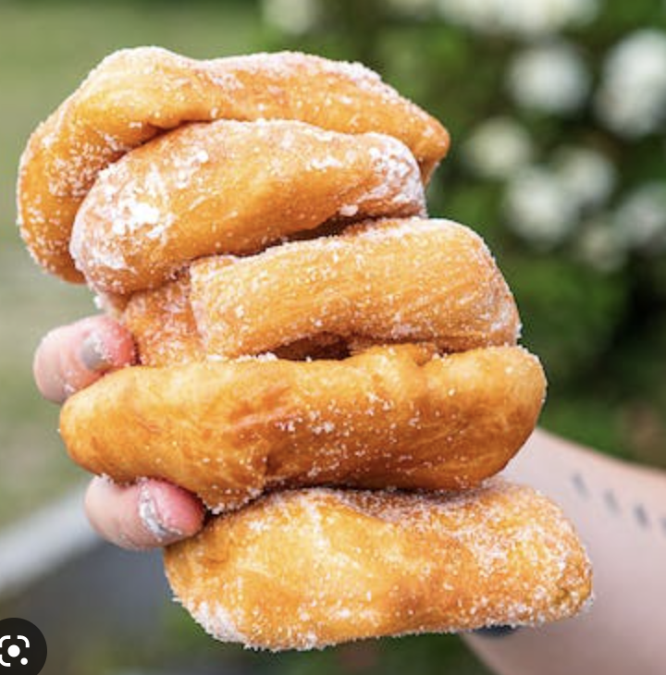
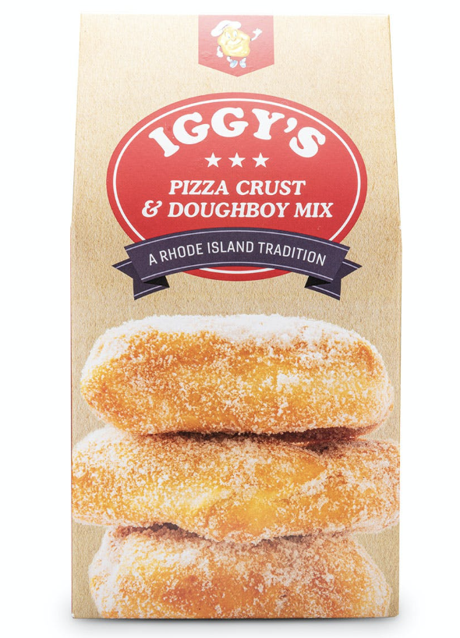

The Market
Market Description
Iggy’s Doughboy Mix is to be sold initially in Lagos. Lagos is Nigeria’s largest city and one of the largest in sub-Saharan Africa. The current metro area population of Lagos in 2022 is 15,288,000, which is the most populated city in Nigeria. Iggy’s Doughboy Mix is to be sold here initially as Lagos is the most developed city in Nigeria, and if it succeeds here, then it will succeed in most other Nigerian cities.
Vehicles are the main way of transportation in Lagos, where there are private vehicles, commercial buses called danfo, and taxis. They are on the go everywhere, as they pick up passengers in garages and bus stops. There are also three-wheeled motorized rickshaws called kekes, which are great for neighborhood shuttles, and motorcycles called okadas, which are the go-to options for people in Lagos when they need to get somewhere quickly. In addition, the Lagos Bus Rapid Transit (BRT) allows hundreds of buses to “zoom down dedicated lanes.” Many people in Lagos, whether citizens or visitors, choose to ride the BRT because they get the opportunity to look at the city and all of its neighborhoods. Bicycles are also commonly used in Lagos, especially when traffic is less on weekends. On top of that, there are ferries and private and traditional boats.
There is little information available about the consumption patterns of pre-made puff puff mixtures or even exactly how many puff puffs are consumed in Nigeria each year. Yet, it is speculated that the number is quite high. There are reviews posted on the internet by Nigerian people that give insight into the consumer preference for pre-made mixes. Many of the claims are that the pre-made puff-puff mixes are, “not bad but [is] not going to be something [they] jump on” purchasing again. They would prefer to keep making their own and deal with the additional steps and less convenient elements of cooking from scratch. Based on these types of reviews, it can be inferred that the product consumption patterns for the pre-made mixes are limited. Since doughboys are a food item that Nigerians have no experience making from scratch, the hope is that they will be more willing to continue purchasing our pre-made mixture even if it is only deemed “not bad.”
Again, there are very few preferences among consumers when it comes to pre-made dough mixes available on the Nigerian market. There is a desire among Nigerians to have an easier process to enjoy one of their favorite snacks but the taste is ultimately the most important aspect. If that is off, there is no preference to have a pre-made dough product, but rather the ingredients needed to make homemade puff puffs instead. We are only selling something similar to a puff puff rather than the actual product itself so we are hoping that the simple cooking experience of a new yet somewhat familiar snack will be a feature that sparks interest.
Since the start of the pandemic, the majority (81%) of the people in Nigeria have shopped online to buy things however grocery goods are typically bought in stores. The fact that most food goods are bought in stores is extremely helpful when importing a product. Typically Nigerians buy most of their clothing and other goods online so they have a high online presence. Also, a key habit is that Mastercard is a huge business in Nigeria. A lot of Nigerians have banking accounts with a master card so most of their payments are on a credit card rather than cash.
Shoprite and Spar Nigeria are retail outlets primarily located in Nigeria and products such as plantains, apparel and accessories, baby food, and many more products are sold. It is similar to a Walmart in the United States, however, this retail store sells many things that Nigerians need for their everyday lives. Our product could be sold here because many Nigerians go here to go grocery shopping or shopping for things.

Competitor's Marketing Mix
Iggy’s Doughboy Mix gives consumers the luxury to enjoy doughboys at any time and any place, as a snack, dessert, or meal. Each package sold in the US market makes two dozen doughboys. The main features on the packaging are the image of the prepared doughboys, the company's logo at the top (little doughboy “man”), and its slogan which reads, “A Rhode Island Tradition.”
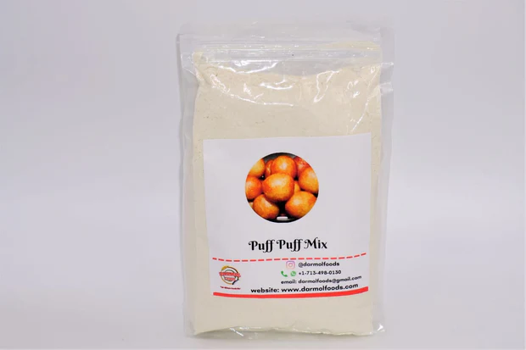
The most similar and popular pre-made dough mix currently available in the Nigerian market is called “Puff Puff Mix,” which is made in Nigeria by Darmol African Market. The pre-made mix comes in a transparent plastic bag, has a picture of the prepared puff puffs that can be made with the mix, and contains the various social media platforms and contact information of the company alongside their logo. One feature this product has that is highly different than what we will offer is in addition to being able to make puff puffs, Darmol’s mix also makes Akara, Bean Cake, Moimoi, and Gbegiri (other traditional Nigerian delicacies). This poses a severe threat to the success of our product since Iggy’s mix only makes doughboys.

Prices
One package of “Iggy’s Doughboy Mix,” sells for $10 USD on the GoldBelly website. This package makes two dozen doughboys. A likely adjustment upon importing to Nigeria would be selling the product for about half the price and product in order to attract consumers to the smaller quantities and again, lower pricing. Thus, we would sell the product for $5 USD and it would make one dozen doughboys.
The Nigerian “Puff Puff Mix” sells for $10 USD on Darmol’s website. This package contains two pounds of the pre-made dough mix, thus being a pretty significant quantity.

Promotion and advertising methods
Content marketing will be important to use when introducing this product so consumers are educated on what is being sold to them. This can be done through videos, paid advertisements, etc. Social media marketing will also be critical to success.
There is little information available about how Iggy’s and its mix are promoted in the United States. This is likely because this food is a “Rhode Island tradition” and does not have much traction beyond Rhode Island or New England residents. Therefore, other than word of mouth, Iggy’s uses point-of-purchase to promote their product in local stores, radio advertisements on local stations, and offering samples during the summertime at local state beaches.
Generally, it appears that pre-made puff-puff mixes have gained traction on the internet through local content creators creating reviews. For example, a video was uploaded by a content creator name “SisiYemmie” with a video titled Bye or Buy? Instant Puff-Puff Mix. In terms of Darmol’s “Puff Puff Mix,” it seems that the majority of their promotion and advertising methods are centered around the internet and social media. Their packaging alone contains their Instagram account name, the company phone number, the company email address, and finally, the link to their website. This gives customers direct access to their promotion methods and shows that they are eager to have a direct relationship with the customers.
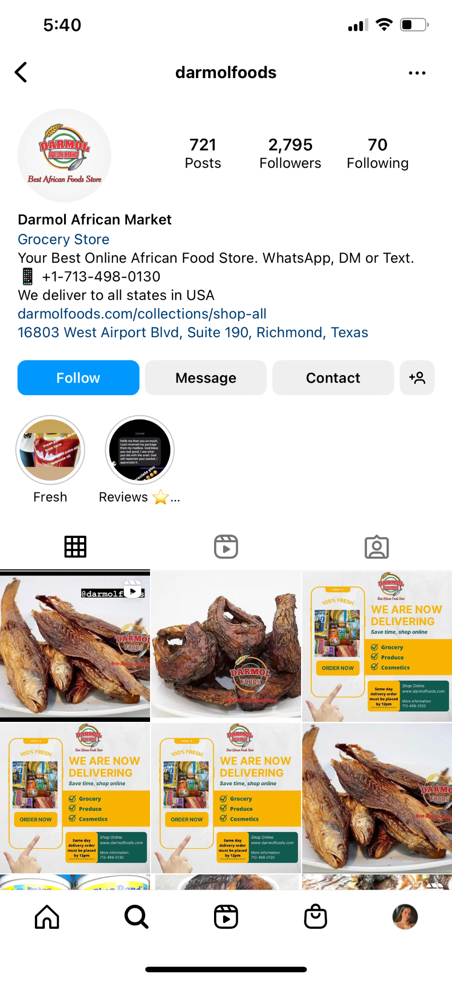
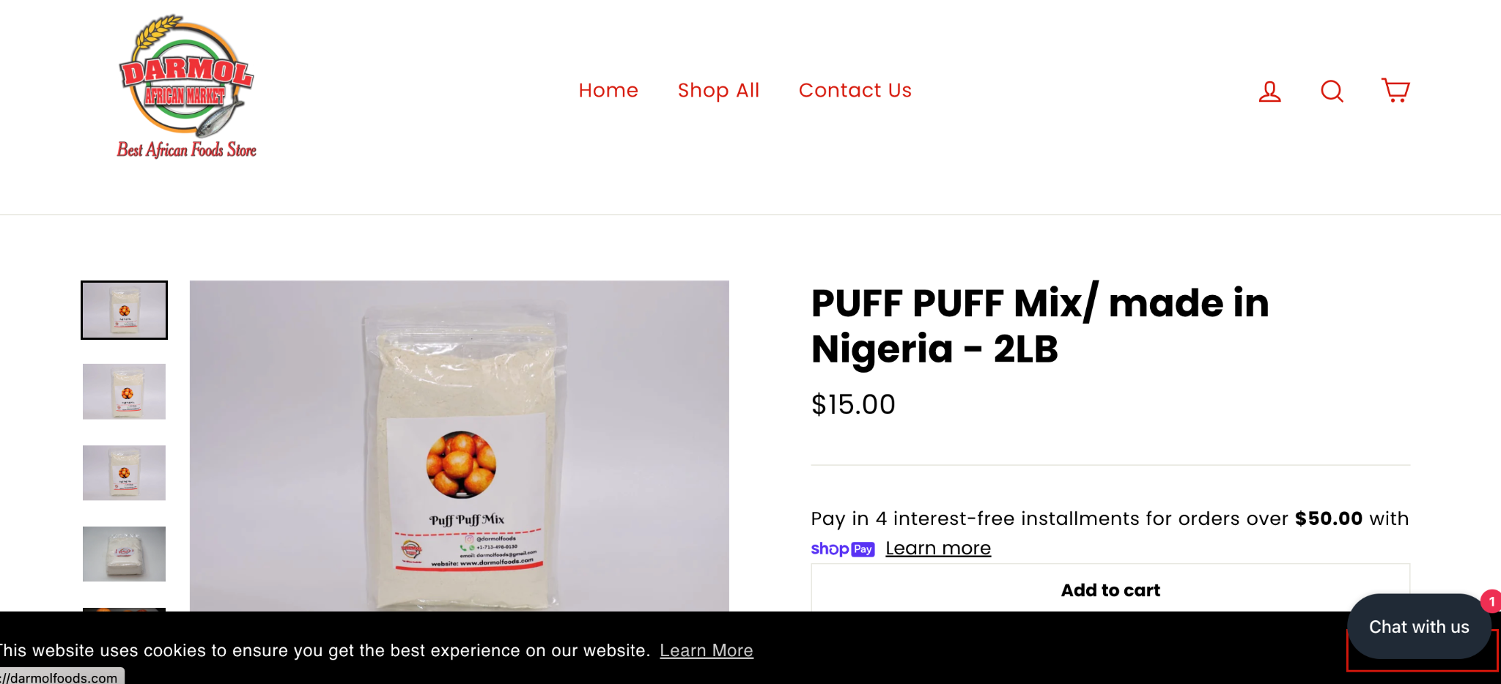

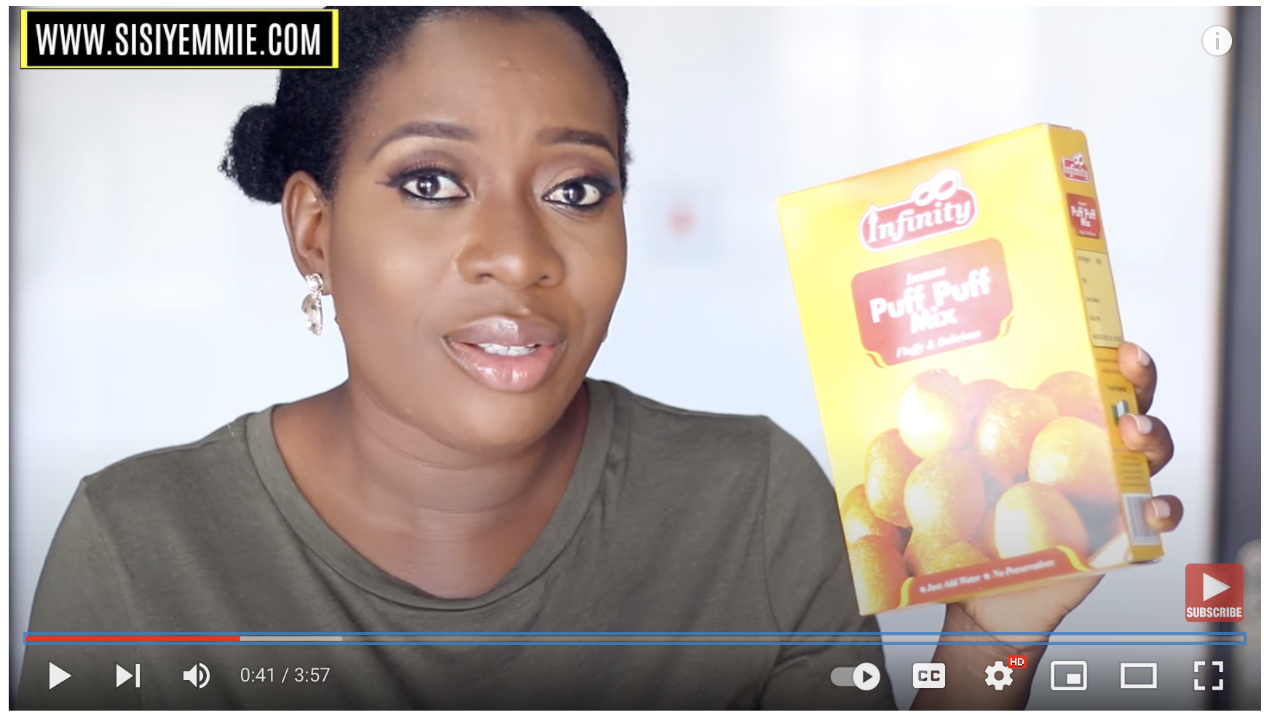

Distribution Channels
In the United States, Iggy’s is currently sold at local restaurants (along with other local foods), at local retail stores, and online through their website and other various platforms. Little information is provided on their website about specific distribution channels so the business would need to be directly contacted to learn more specific information.
Darmol’s Puff Puff Mix is readily available online, both through their direct website and other sources. It also mentions that the product is found in local retail stores but does not provide information about the names or locations of the facilities. This is a benefit for us as we import our product into Nigeria since the customers are already familiar with our intended form of distribution since it is being done by our competition as well. Regardless, partners and intermediaries will need to be established in Nigeria so this American product can become more than comfortable sitting on Nigerian shelves.

Government Participation
We could use the Export-Import Bank in the United States of America. The Export-Import Bank is a government agency used to help export American goods and services to other countries. The bank helps mostly small businesses and corporations. It would also be helpful for us because there is no transaction that is too small for the bank to consider so even though we may not be importing large amounts of the product we would still be able to utilize the bank and its services.
Importing to Nigeria has a few challenges and there are specific regulations and inspections that will need to be followed. Specifically, foods need to be inspected by government officials or a third party. When importing into Nigeria we would need to present a Bill of Lading, Commercial Invoice Exit Note, duly completed Form ‘M’, Packing list, Single Goods Declaration, and a Product Certificate. Because of the pre-arrival report system in Nigeria we can submit all of our documents online so that our import does not get held up at the dock and can be sold and imported into the country quicker. Depending on whether we choose to ship our product on a plane or a boat, the regulations differ slightly. We would need to label the cargo with the import duty report on the shipping manifest or the airway bill.
It could be beneficial to have an export specialist on board to ensure that all of the regulations have been followed and that we have properly inspected our product. This would be beneficial so that our products can efficiently make it to Nigeria with no issues or hold-ups. We want our product to be made as fast as possible so that we can begin to make a profit on our product as fast as possible.

Works Cited
Export assistance. United States Trade Representative. (n.d.). Retrieved December 6, 2022, from https://ustr.gov/trade-topics/trade-toolbox/export-assistance
How to get around Lagos like a local. Lonely Planet. (2022, August 13). Retrieved December 6, 2022, from https://www.lonelyplanet.com/articles/getting-around-lagos
Iggy's Doughboy Mix. Goldbelly. (n.d.). Retrieved December 6, 2022, from https://www.goldbelly.com/iggys/iggys-doughboy-mix
Nigeria - Trade Barriers Nigeria - Trade Barriers. export.gov. (n.d.). Retrieved December 6, 2022, from https://legacy.export.gov/article?id=Nigeria-Trade-Barriers
“Puff Puff Mix/ Made in Nigeria - 2lb.” Darmol African Market, https://darmolfoods.com/products/puff-puff-mix-made-in-nigeria.
What is a distribution channel? Salesforce.com. (n.d.). Retrieved December 6, 2022, from https://www.salesforce.com/eu/learning-centre/sales/distribution-channels/

Preliminary Marketing Plan
The Marketing Plan
Marketing Objectives
In Nigeria, a delicacy is a Puff Puff pastry, they also eat many fried foods for breakfast and other occasions. Our target market will be people who enjoy fried puffs. Our primary target market will be the people of Eastern Nigeria, such as the LGBO and IBO because they primarily eat foods such as Gari. Gari is a cassava powder used to make baked goods. The eastern Nigerian people tend to eat a lot of fried goods such as fried plantains, and puff puffs. This is why we feel that this will be our primary target market when entering our product in Lagos, Nigeria. We will also target families who have children because the children in Nigeria like to eat puff puffs which is a Nigerian fried dough food. They make this on holidays, so by having our prepackaged product for a puff puff it will be easier for families to obtain this for their children instead of having to make it. This makes the age range of our target market rather broader, anywhere between the ages of 14-44 years. The target market is not limited to this age distribution, but this is the group of people that we believe our product will resonate with the most and also targets the age groups that most align with children and families. For this reason, we believe that directing the majority of our marketing efforts to these age groups will help to develop a stable group of consumers relatively quickly in the marketplace.
The population of people aged 14-44 in Lagos, Nigeria is 11,852,000. We want to be conservative in the first year with a 10% market penetration, equating to about 1.2 million people in the first 12 months if only selling to individuals. Likewise, there are 4.75 million households in Lagos so with 10% market penetration in the first year, we would be targeting 475,000 people. Therefore, if we would like to sell one package of Iggy’s doughboy mix per person, we would sell 14.4 million units in the first year. If we sell one package per family, we would sell about six million units in the first year. Since we want to target both individuals and families, we expected our units sold in the first year to be somewhere in this range.
In dollars, the pre-made mix packages we plan to sell in Lagos will cost about $5 USD. This price comes from planning to distribute the packages to produce half the amount of doughboys as the ones currently sold in the United States (one dozen versus two dozen). There is a 10% tariff on intermediaries goods imported into Nigeria from the United States. The 10% sales on the doughboy mix packages will bring $1,200 USD of revenue and total sales for the first year.
To be conservative, we would like market penetration and coverage for the first year to be 10% to build brand awareness. In the second year, we will still want to be conservative but increase our percentage slightly to 15% as we move more toward brand recognition. Finally, in the third year, we hope to have 25% market penetration as brand loyalty starts to build among original customers while also continuing to acquire new customers and gain recognition in other markets as well.

Product Adaptation or Modification
Packaging will be adapted from the local Rhode Island and United States versions of the product to appropriate metrics and to a design that is more suiting and appealing to the typical Nigerian consumer. We will start by adapting the logo and slogans on the packaging because the design is traditional to the State of Rhode Island and has red, white, and blue coloring (similar colors to the American flag). We will work to adapt a new slogan specific to the culture and likely have the packaging contain the colors of the Nigerian flag. We intend for this logo to read, “A Sweet Nigerian Delicacy” because we are trying to promote this product as being a ‘sweet’ version of the puff puff and also it honors the slogan on the original packaging by mentioning the place of distribution.
Additionally, when prepared a certain way, the mix can also be made into pizza dough. This is not something we wish to sell or advertise when selling in Nigeria and do not want to incorporate it into the packaging or advertising of our product. The phrase and directions for pizza crust will be removed from the packaging entirely and only feature the doughboy. Currently, a single package of Iggy’s Doughboy Mix will make two dozen doughboys. We plan on reducing this to one dozen doughboys per package when initially selling this to Nigerian consumers. The little Iggy’s doughboy is the mascot featured at the top of each United States packaging but this will be removed since this mascot holds very little significance beyond the Rhode Island border. Therefore, we have chosen to replace the original Iggy’s mascot on the American packaging with an eagle, Nigeria's national bird. To incorporate doughboy features into this new icon on the Nigerian packaging, we have placed a sweet, tasty doughboy in his mouth that is consuming as he flies away. All writing will be in English and the front will read, “Iggy’s Doughboy Mix '' and the side will have the directions to prepare the doughboy exactly as listed on the American packaging.

Promotion Mix
The objective of Iggy’s advertising in Lagos is to offer consumers an alternative form of a delicacy they already enjoy. Some of the advertisements produced will be used to establish a relationship between items like puff puffs and doughboys while others will be used to educate consumers on the similarities and differences between what they are accustomed to and the new item we want to introduce. We also want our advertisements to show people either enjoying and supporting the product or wanting to try it for themselves, so this will be implemented in ads we produce as well. Overall, if there is no proper understanding of what a doughboy is, the brand will not be able to create a market and ultimately be unsuccessful.
The message surrounding the advertisements will be a sweet and delicious alternative to an existing delicacy. The purpose of Iggy’s product is to promote a sugary, deep-fried version of traditional Nigerian food to create new excitement about customary food. Messaging will be straightforward and simple to follow instructions. The packaging will include messages, coloring, and designs geared toward gravitating consumers toward the purchasing product but remain visually appealing and interesting to consumers. The advertisement will focus on making the doughboy look familiar so consumers associate it with puff-puffs and appetizing so they will hopefully continually want to use the product.
We believe that the use of interest and social media is a very effective and cost-efficient way to reach the majority of our target market. Both interest and social media are lower-costing forms of media coverage available across Nigeria. Specifically in Lagos, AdHang offers social media management that costs $28 per day and includes planning, designing creative works, strategizing, running, and managing social media accounts. They use platforms such as Facebook, Twitter, Instagram, etc. The price includes sponsored ad displays, professional advert creation, and promotion management by the agency. However, the $28 is only for one media site, so if we would like Iggy’s doughboy mix to be shown on two platforms, the price would be doubled. The estimated daily reach for the $28 ad is between 10,000 to 25,000 impressions and from there, word of the product could also expand by screenshot, mouth, and beyond.
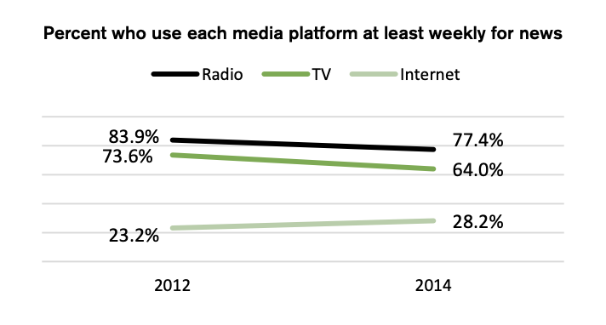
We also want to utilize radio because this is the dominant news platform in Nigeria, with 77.4% and more than seven in 10 across all major demographic groups saying they listen to the radio for news weekly. TV is also a dominantly used media form, so we would like to promote the product through that platform as well. Most Nigerian homes also have operating TV and radio stations, making these devices that are likely used often and would help us reach potential customers faster. The cost of a 15-second radio advertisement in Nigeria is NGN 8,000 (5% VAT of N400) and the cost of a TV ad is between NGN 100,000 and NGN 250,000, depending on the channel where the advertisement is broadcasted. The price of airtime and viewership would both be considered in determining how we choose to advertise via TV.

We plan to spend 15%-20% of the revenue gained from Lagos on advertising the product. This is a reasonable percentage because we will initially need extensive advertising to prove to consumers this seemingly very different-appearing product is that very different from a delicacy they are already familiar with. Brand awareness in a new market and various forms of advertising will be costly, particularly in the early stages. The market must be educated and familiar with the brand's purpose for the product to be successful. For this reason, we believe that 15% of revenues are sufficient funds to initially support our successful marketing plan and campaign.

Sales Promotion
The goal of our sales promotion is to encourage customers to try our sweet, deep-fried sign on a familiar product at an affordable price and reasonable size for immediate purchase. Nigerian consumers will likely see some culturally familiar aspects in the product but also notice some distinctive differences that could either spark interest or deter them entirely. Selling in a relatively small package size and at a lower price will likely mean consumers will be more likely to purchase an initial mix. After gaining brand awareness from the marketing campaign, it is hoped that consumers will develop a liking for the sugary, deep-fried treat and be more likely to continually purchase.
A specific sales promotion we plan on implementing is 40% off the first package purchased so consumers may be able to first try the product at an even furtherly discounted price. This might initially harm revenues but with the intent that they will only grow by consumers start to purchase more of the item. We will also set up sample stations (similar to those in American stores like Costco) where consumers can try the actual product in-store to make a definite decision before purchasing. This could turn people off to the product if they receive a bad sample or simply do not care for the doughboy. But it could also make people realize they like the product more than they expected and buy the packages in bulk with the 50% discount.
Currently, about 10% of the revenue that is gained from Lagos, Nigeria will be used to cover the sale promotions cost. With the promotional forms we have implemented, we feel that it is to have at least a 10% budget of the revenue so there is enough money available for appropriate promotion. As the education of doughboys increases and brand awareness, this percentage can likely decrease but given the new nature of this product, we would rather overestimate initially rather than have insufficient funds.
- Product website: A product website specific to the Nigerian market will be beneficial to support the product. This link will tentatively be “www.iggy’sdoughboynigeria.com.” American websites promoting the product have a Rhode Island scope and aesthetic since doughboys are RI traditional. Having a website devoted to the adapted product we plan to sell in Nigeria will allow us to showcase the product in that specific scope and present it in a frame that is more appealing and easier to understand by the Nigerian market. The updated packaging size, design, and the price will all be featured on this Nigerian product website, along with a story explaining the similarities to puff puffs and other dough-based products already available in the market. We could also explain how the doughboy will be different from the type of deep-fried products they already have and know while framing them in a positive and intriguing way and different than the most similarly competitive products.
- Social media: Nigeria has a relatively high portion of the population using mobile cellular telephones so advertising through social media could be beneficial. Social media is currently a very popular way to prompt new products in any marketplace and is a relatively inexpensive way to start creating brand awareness. This could start as simply as informing consumers when the product is coming out, posting photos of it on shelves, or even pictures taken of those trying and enjoying the product for the first time.
- Celebrity Endorsement: The most famous celebrities out of Nigeria that also have an international footprint are those in the music industry. One of these celebrities is Ayodeji Ibrahim Balogun, professionally known as WizKid, who was born in Ikeja, Nigeria. Some of his most famous songs are “Essence (feat. Tems)” and “Call Me Every Day (feat. Wizkid)” (originally sung by Chris Brown).” He is currently set to go on tour in the United States in 2023. fans describe WizKid as a “foodie” for constantly posting on Twitter about missing his traditional Nigerian foods. Therefore, due to his passion for food, international dominance in the music industry, and respect among Nigerians, he seemed like a fitting figure that could invoke excitement in customers about wanting to try the product since he is likely a figure people feel they can trust the endorsement of.
- Event: Every year, EatDrinkFestivial occurs in Lagos, Nigeria, and is the leading celebration of food and drinks in the country. The event features an extensive selection by some of Lagos’s best chefs, restaurants, and street food vendors. This event was interpreted in 2020 due to COVID-19 but returned in 2021 and is set to continue this year as well for its sixth year of operation. Tickets for the event are available for purchase at various prices depending on the ticket type. Given the popularity and excitement of this festival, Iggy’s wants to be a vendor in future year’s festivals. This would be the ideal environment to encourage customers to try new foods and is an excellent opportunity to sell food in smaller quantities for a discounted price, which would hopefully induce sales.

Distribution
We will be using The Port of New York and New Jersey located in Port Newark, NJ. Features of the Port Newark Container Terminal include 272 acres of the terminal area, a ship berth length of 4,400 feet, and 13 total container cranes. Equipment available includes empty container handlers, yard hustlers, straddle containers, reach stackers, and more. This is the largest seaport on the East Coast and provides excellent service, so we will be responsible for transporting the packages of doughboy mix from Rhode Island to New Jersey and shipping them overseas.
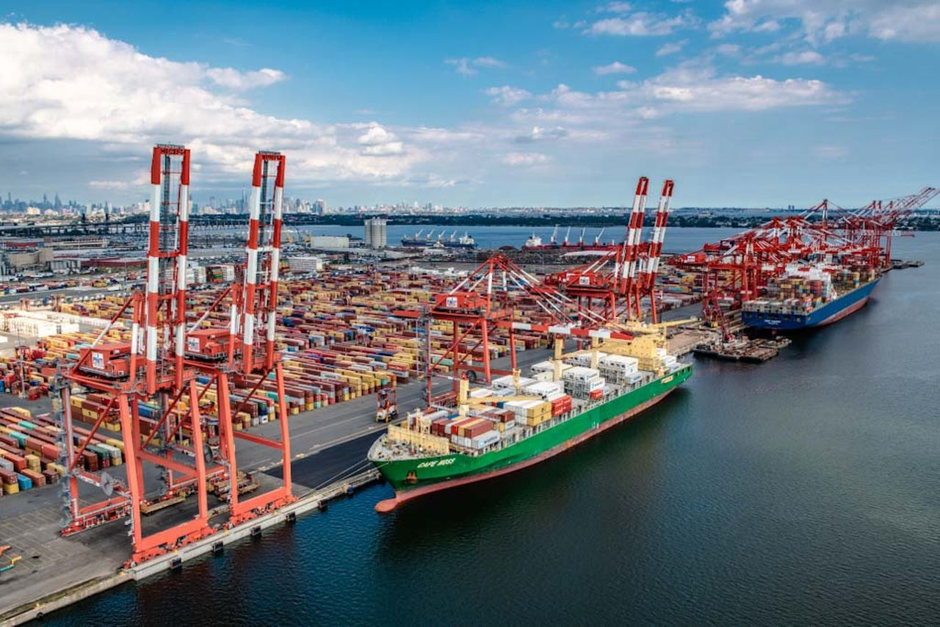

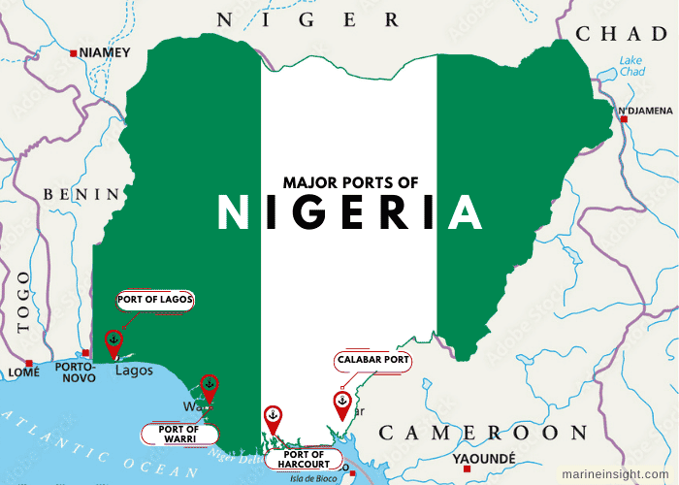
We will ship our product to Lagos Port Complex, situated in Apapa, Lagos State. The port is cost-effective and customer friendly as it is equipped with modern handling equipment and personnel support facilities.

This satellite image shows the distance between The Port of New York and New Jersey in Port Newark, New Jersey (green dot) and the country of Nigeria, where the Lagos Port Complex is located (on the border of Benin).
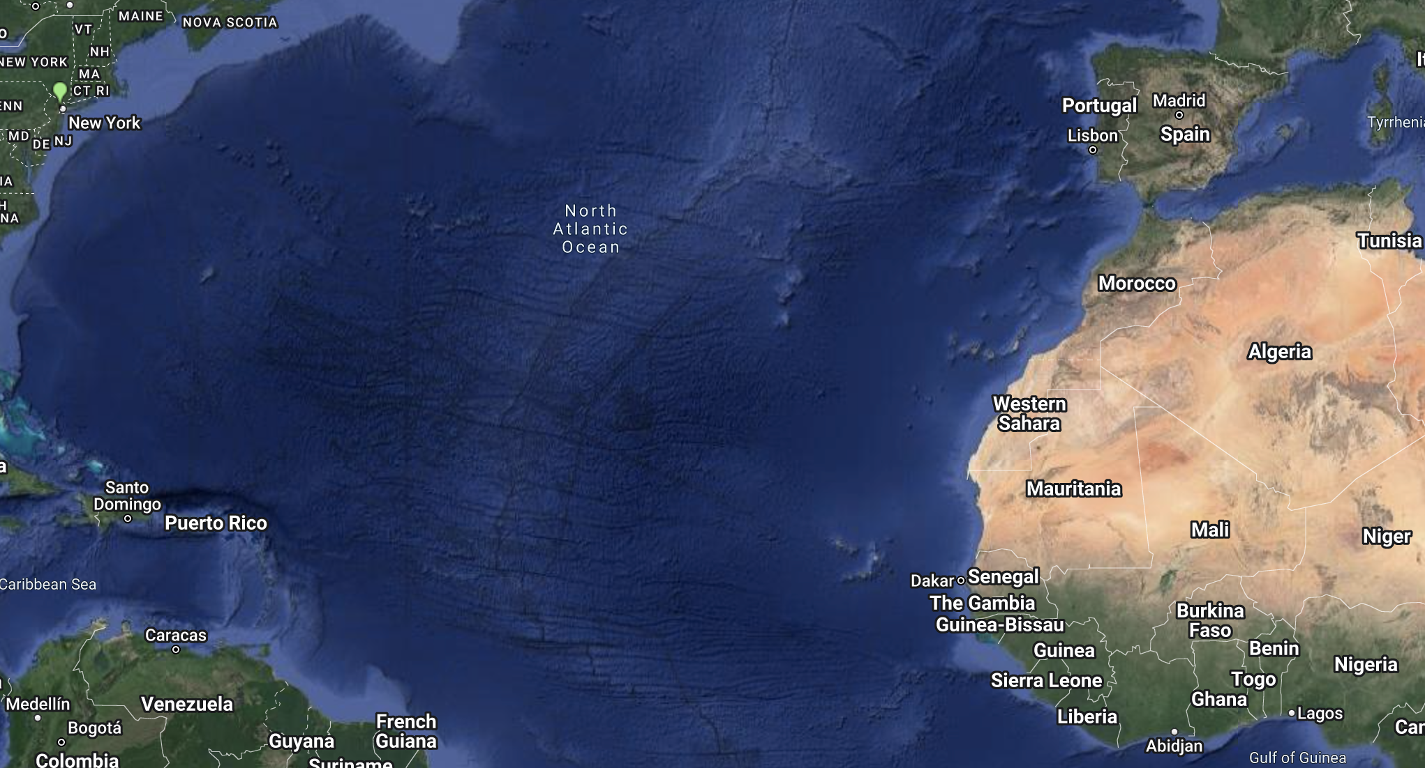

Mode Selection
The image above shows the railway system in Nigeria. Although there are few routes, this mode of transportation is not what would work within our country and for our product. The railways are not kept up to date and maintained therefore this could potentially create issues for shipping products and transporting products into different regions of Nigeria. Only a small percentage of goods are transported on trains within Nigeria, therefore, this is just not a good option for us to use when exporting our product.
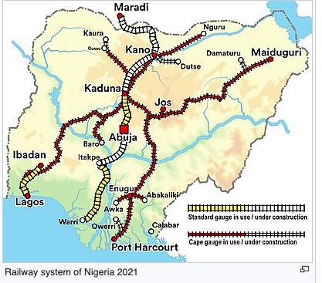

In Nigeria, there are many rules and regulations for importing goods on air carriers, which makes it extremely difficult to transport goods in this way. Nigeria also has only 54 airports within the whole country and 14 of them have unpaved runways. Only two airports have long runways which would be better for delivering cargo and goods. Although this might be the fastest way to transport goods, we will not be using it because of the other issues that go with airports and air carriers in Nigeria. Using alternative methods of transport will subsidize the number of mistakes that could be made and it would be better when shipping doughboy products across international borders.
Nigeria uses ocean ports to import and export goods very often and they have 6 major ocean ports. This is the primary way of receiving and transporting goods into and out of the country. We feel that this will be the best way to import our goods into the country. The country also has 8,600 km of riverways to transport goods throughout the country. More than half of Nigerians use ocean ports to get goods, and over 1000 vessels each year carrying around 5,700,000 tons of cargo go into these ports. Ocean carriers are a primary way that Nigeria trades with other countries and gets goods. This is one mode that we will be using to transport our goods from the United States into the country of Nigeria.
80% of Nigeria's population uses roadways so this is the primary way of transportation within the country. To transport our goods to retailers we will have motor carriers pick up our shipments from the ocean ports and take them to the retailers. Nigeria has many roadways and they keep up with the maintenance of roadways so using motor carriers allows us to have smoother shipments to transport our goods to their final destination.

Packaging
In Nigeria, it's very important that when shipping a package into the country either through air cargo or ocean ports IDR numbers are always quoted on the shipments. IDRs are Import Duty Reports and these must be submitted to Nigerian Custom Officials in order for them to know what is in the shipment. In addition to this, the Nigerian Government also has many requirements when shipping products into the country. These requirements are having the name of the product, country of origin, specifications, date of manufacture, batch or lot number, and the standard at which they were produced like BS, DIN, ISO/IEC, and NIS. Since we are shipping a food item we have to make sure that it has the expiration date and the ingredients labeled on the packing. Each product also has to be in metric measurements and can not have alternative markings otherwise the country will refuse to take the item.
In Nigeria it is mandatory that all containers are palletized, this was issued in form M after January 1st, 2018. There are some expectations though for palletizing contains thus if any single item weighs more than 1000 kg they do not have to be palletized. Another is any items that are rolled out by containers, such as vehicles. Also by packing containers so if the stuffing in the container allows a person to walk inside it does not have to be palletized. The final expectation is on how fragile the item is, if an item is too fragile to be offloaded this would be considered a specialized container. Some other requirements with containerization are that Form M has to be put on the Bill of Lading. Diplomatic goods also need to be on the Bill of Lading, and finally, any cargo under fast track must be on the bill of lading. If these requirements are not met then Nigeria has the right to refuse the shipments as well as fine the authority who delivered the shipment.

Channels of Distribution
We would be interested in selling our product in grocery stores. One of the biggest supermarket chains in Nigeria is Spar Nigeria. There are 14 Spar supermarkets in all different areas of Nigeria and it would be beneficial to sell our products in these stores. We also looked at Shoprite which has a high presence in Nigeria as well. Shoprite has 25 different locations in Nigeria. It would be important to have our product stocked in multiple different supermarkets so they are accessible in different locations and places in Nigeria.
Shoprite and Spar Nigeria are both supermarkets that sell Nigerian food and other food options as well. Since our product is food and can be sold in boxes, shelf life is not a major concern. We would be able to ship bulk amounts of our products directly into Nigeria and have them transported straight to the grocery stores.
There is not enough credible and accurate information provided on retailer markups in Nigeria so we will assume at least a 1% markup. Given our selling price of $5 USD, this would mean it would cost $5.05 USD with a 1% retail markup.

Price Determination
We are going to ship by ocean carriers from the Port of New York and New Jersey to the Lagos Port Complex. We will also require motor vehicles to get the product from Rhode Island to the New Jersey port and then another set of vehicles to transport it from the Lagos port to the final retail destinations. The exact quotes for these services are not available on the company's website, but only by calling to speak with a representative.
The import tariff for intermediary goods is 10%. We will have to factor in the extra cost of the tariff when evaluating our total expenses. There is not enough information provided on retailer markups in Nigeria but we will assume at least a 1% markup, which is standard for most retail stores.
Within markets in the United States, the doughboy mix is sold to make 2 dozen doughboys. We are going to sell a one-dozen mix in Nigeria for half the price it would cost for the two-dozen mix. However, it is known that people living in underdeveloped countries prefer not to buy and eat in bulk so we found that lowering the amount the mix makes would benefit Nigerians more and would sell more. This will also allow us to sell it at a reduced cost.
Finally, we will be using penetration pricing when setting the price of this product in the Nigerian market. Since this is a new product, we do not want to set the price too high to deter customers so we will use penetration pricing so it is consistently being sold at a low cost.

Works Cited
1. “Nigeria - Labeling/Marking Requirements.” International Trade Administration | Trade.gov, https://www.trade.gov/country-commercial-guides/nigeria-labelingmarking-requirements.
1. “Nigeria - Trade Barriers.” International Trade Administration | Trade.gov, https://www.trade.gov/country-commercial-guides/nigeria-trade-barriers#:~:text=The%20tariff%20has%20five%20bands,on%20imports%20into%20strategic%20sectors.
AM and SW Use Declined Contemporary Media Use in Nigeria - U.S. Agency ... https://www.usagm.gov/wp-content/media/2014/05/Nigeria-research-brief.pdf.
“Containerport Information: Port Authority of New York & New Jersey.” Containerport Information | Port Authority of New York & New Jersey, https://www.panynj.gov/port/en/index.html.
“DSTV Nigeria Advert Rates and Cost of Advertising on TV Stations in Nigeria.” Alternative Advert, 16 Aug. 2021, https://alternativeadvert.com/blog/dstv-nigeria-advert-rates-nigeria-tv-cost/.
“Maps, Analysis and Statistics about the Resident Population.” Age Classes by GenderMunicipality of LAGOS, Old-Age Index and Average Age of Residents, https://ugeo.urbistat.com/AdminStat/en/pt/demografia/eta/lagos/20318857/4.
“Social Media Management Cost in Nigeria: Promotion Charges 2022: Marketing Managers Lagos.” AdHang Ltd | RC: 1931413, AdHang Ltd | RC: 1931413, 9 May 2022, https://www.adhang.com/social-media-management-cost-in-nigeria/.
Writer, Staff. “There Are 4.75 Million Houses in Lagos, Government Says.” Connect Nigeria, 12 Feb. 2013, https://articles.connectnigeria.com/there-are-4-75-million-houses-in-lagos-government-says/.

Appendix

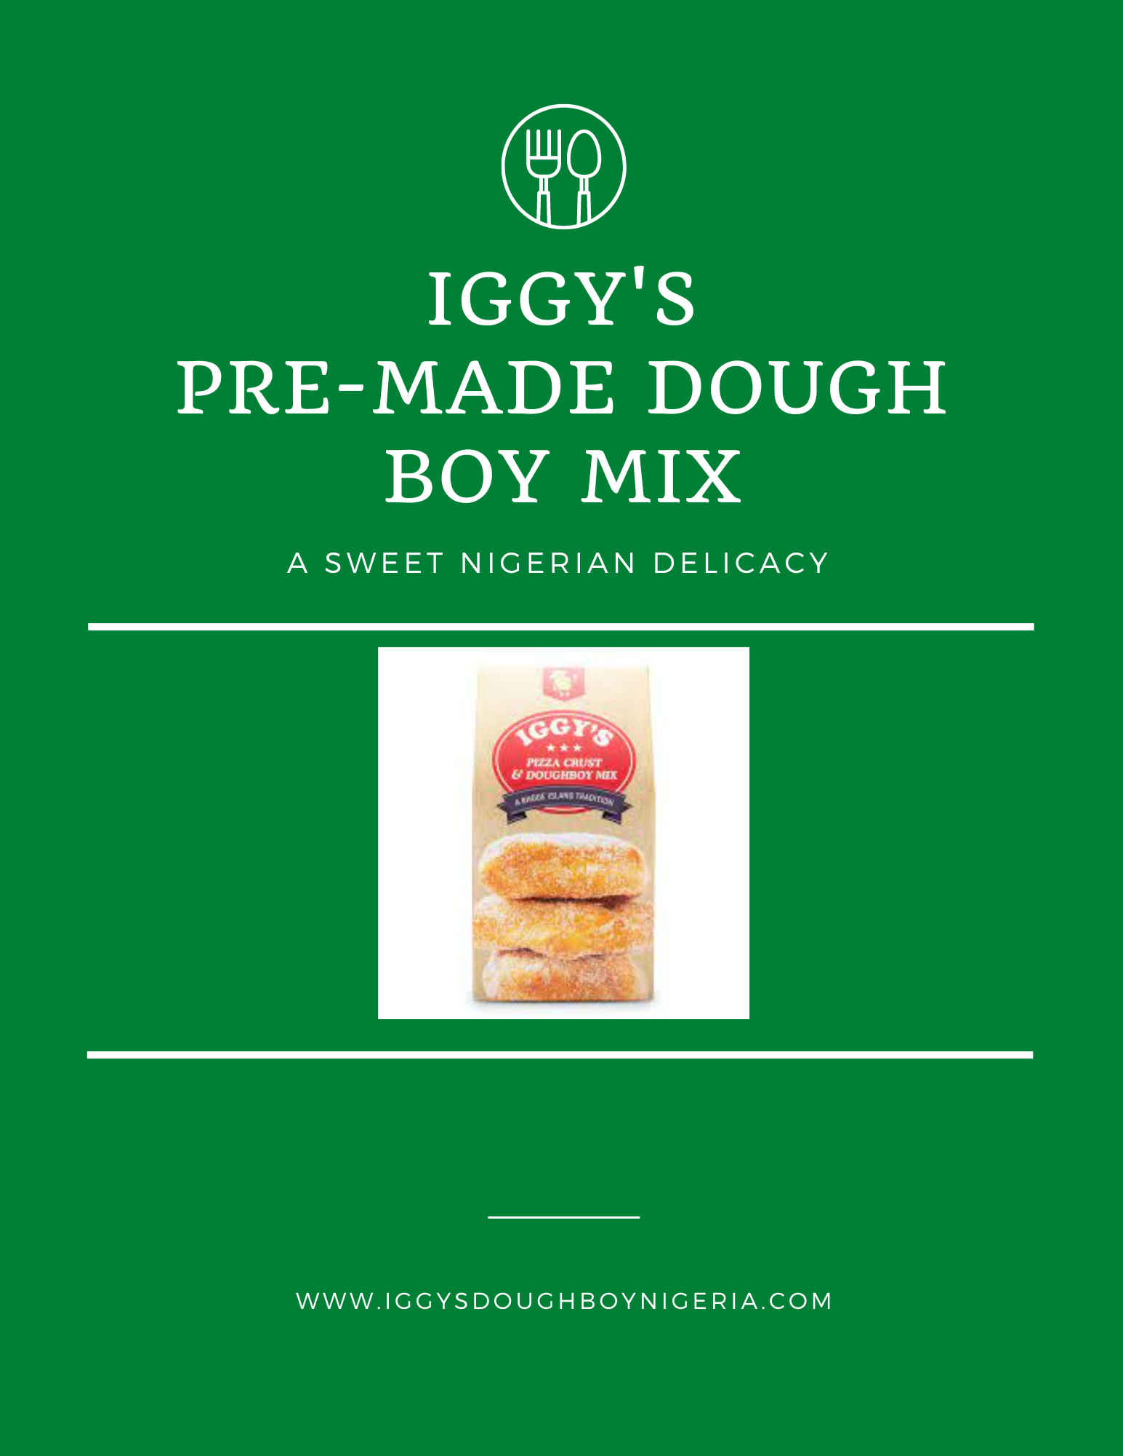
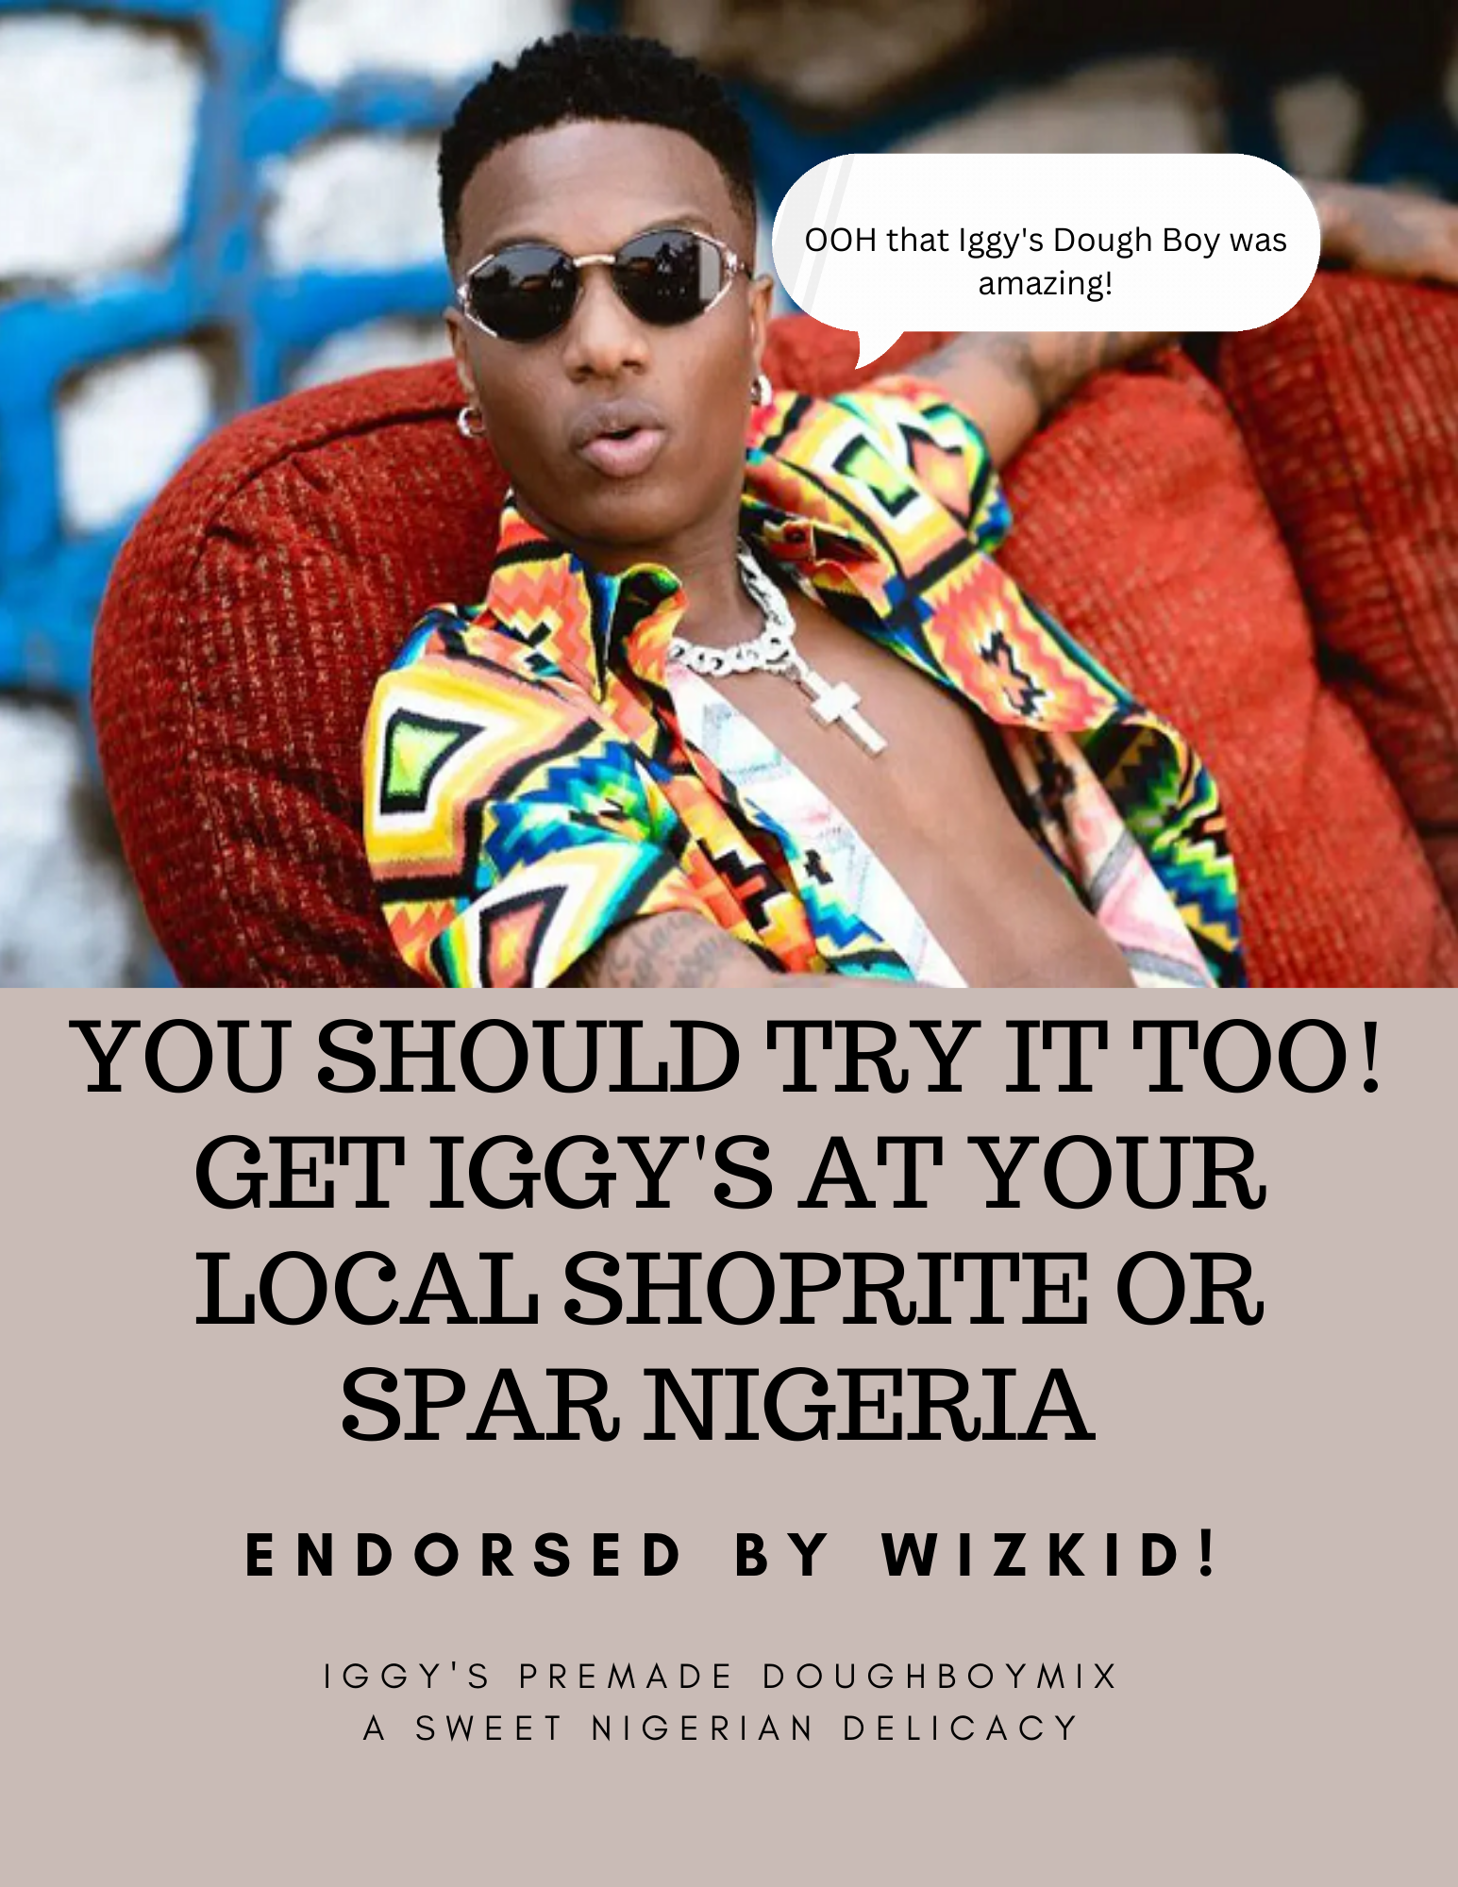

He wants to know more, you should too.
"Mom, what's Iggy's?"

IGGY’S
“A Sweet Nigerian Delicacy”

